**Important links**

* [Ads EP Dashboard on Control Center (WIP)](https://docs.google.com/document/d/170IJO6VHVQFNRO9gSAeqlQNojnj6tMktT63tsnl_35k/edit#)
* [Data Collection for EP Flow Dashboard](https://docs.google.com/spreadsheets/d/1L5zOjK4ZJYBAZb3me51ujIpBAL5vgixsw6RXAcLUxvw/edit#gid=0)
* [Epchange Agile Board (JIRA)](https://jirap.corp.ebay.com/secure/RapidBoard.jspa?rapidView=24427&view=detail&selectedIssue=SHEPHERD-512&quickFilter=59722)
* [#ep-change-metadata (Slack)](https://ebay-eng.slack.com/archives/C02K5NJ73FZ)
* [Plan schedule](https://jirap.corp.ebay.com/secure/PortfolioPlanView.jspa?id=4321&sid=4321&vid=1042#plan/backlog)
* [​​Control Center “Changes” Feature Discussion](https://docs.google.com/document/d/1kmoamgESWhwOv3UAyq-Wz4R1-CHUKPb0-yd8cGOYD4s/edit#heading=h.l4jaeyru1utq)
* [Keystone OA](https://docs.google.com/document/d/1aVeBNRz4UaLJ_3Tk5bBe2CYYWYNW_dMLCwFwtWw6k4c/edit)
* [Q1 Q2 metadata change project](https://docs.google.com/document/d/1GB13ASrm3dsN-a4oR6XxIjSau18krfbYvO5hPxTLRDQ/edit)
* [#merch_ep_nrt_metrics](https://ebay-eng.slack.com/archives/C03N05HK9RS)

**Extra reads**

* [Algo Targeting(ALGO.OVERRIDE) - A new format for merch algo testing on EP, with best practices.](https://wiki.vip.corp.ebay.com/pages/viewpage.action?pageId=873072778)
* [EP NRT monitor demo](https://hubtv.corp.ebay.com/#/media/zR6A3p)

# Sep 29, 2022

Move meeting to once a month

Analytics team NRT - PM might use this more. We may not get a lot of feedback from the EP NRT monitor for now.

We can still keep using EP NRT monitor for placements

# Sep 22, 2022 no meeting

Email Thread

* @Xiao, Hancheng have we set up alerting rule for any business drop say after an EP is activated?
* Hi Pavel, We didn’t set up alert rules, instead whenever EP activated the notification service will send out ramp up email contains the corresponding EP NRT monitor link ask owners to manually check.
* What if owners forgot to check? 😊
* Yeah we can check with different EP domain owners to identify their desired alert rules, and see how to implement these into control center.

# Sep 15, 2022

To do:

**Wait for feedback from PMs on EP nrt monitor**

* Dawei to send out survey for both EP nrt monitor and email notifications

Xiaoyue -> to contact Arman.

Hancheng

* refactor with pending PR to fix infinitely loading with query and ordering of EP Type and Select Experiment
* Feature
  + 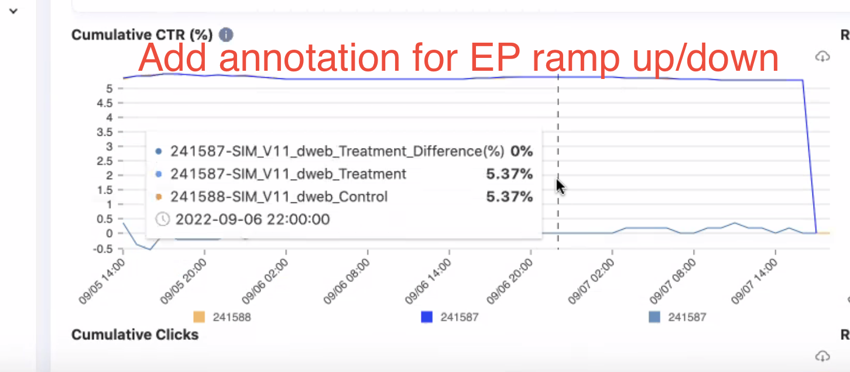

# Sep 8, 2022

To do:

**Wait for feedback from PMs on EP nrt monitor**

* Dawei to send out survey for both EP nrt monitor and email notifications

Xiaoyue -> to contact Arman.

Hancheng

* refactor with pending PR to fix infinitely loading with query and ordering of EP Type and Select Experiment
* Feature
  + 

# Sep 1, 2022

To do:

Input from Yixin 3 months ago. How to define the importance of xt to pageOpt. Also, on why et is not working.

**Wait for feedback from PMs on pageOPT nrt**

* Sales information to be involved in the same page.
* Touchstone integration

Solicit PM feedback. Maybe do it individually.

Maybe ask Dawei to solicit if he wants further requirements

pageOpt UI feedback from CCOE - pending PR: bug fix and refactor - localization.

# Aug 25, 2022

To do:

PM discussion/meeting for PageOPT

Sprint Demo for PageOPT

Sprint Demo for email notifications

Clark

Ep info index

​​

EP Info: <https://esadsquality-kibanaslc.vip.ebay.com/app/discover#/?_g=(filters:!(),refreshInterval:(pause:!t,value:0),time:(from:now-30d,to:now))&_a=(columns:!(_source),filters:!(),index:daec2800-23c6-11ed-a43e-8be9c1dbdde8,interval:auto,query:(language:kuery,query:''),sort:!())>

EP Treatment: <https://esadsquality-kibanaslc.vip.ebay.com/app/discover#/?_g=(filters:!(),refreshInterval:(pause:!t,value:0),time:(from:now-15m,to:now))&_a=(columns:!(algoFamily),filters:!(),index:e42b4090-23c6-11ed-a43e-8be9c1dbdde8,interval:auto,query:(language:kuery,query:''),sort:!())>

EP History: <https://esadsquality-kibanaslc.vip.ebay.com/app/discover#/?_g=(filters:!(),refreshInterval:(pause:!t,value:0),time:(from:now-15m,to:now))&_a=(columns:!(_source),filters:!(),index:ec12b860-23c6-11ed-a43e-8be9c1dbdde8,interval:auto,query:(language:kuery,query:''),sort:!())>

Hancheng

Data is enough to monitor for PM

Data is in prod for both rheos and ES

Migrate the resource in new resource in Control Center

Onboarded the results in NRT page

Different EP Type

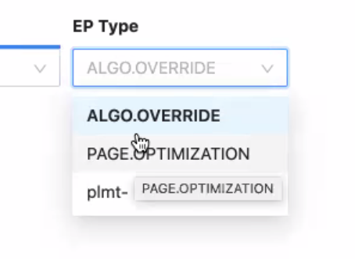

Will change different items in Select Experiments

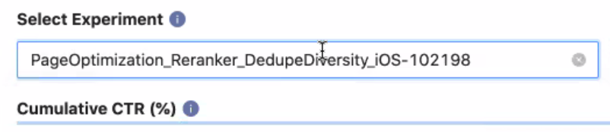

EP xt and et

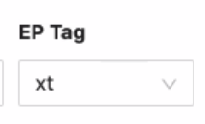

Timestep

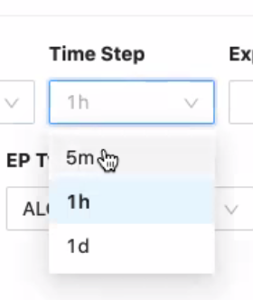

No results could be EP has been completed within the Time Range

Use EP id if cannot find in Select Experiment

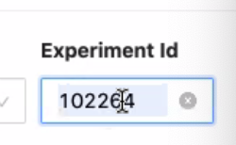

**Feature is in pre-production**

EP Type

plmt- (older syntax)

* Search for factor name plmt
* Home page still using this syntax
* Some of EP is in merch
* To be deprecated

Treatment breakdown

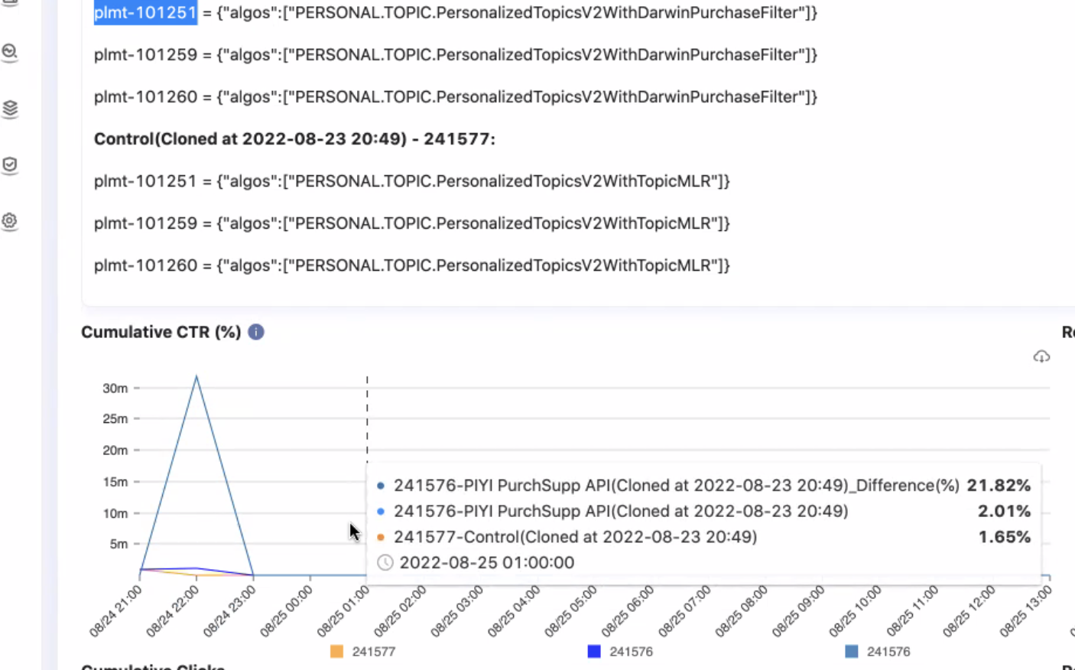

**September Sprint Review Demo for hancheng**

Have JIRA ticket for UI changes

If JD asks whats the difference between xt and et tag.

EP tag info hover explaining xt and et.

Switch order of Select Experiment and EP Type.

Maybe add EP owner

Show to PM

Josh Bligh

**Dawei - to schedule meeting for PMs**

Xiaoyue

Chat with John Yu for email validation notification

Jenkins job

When you setup the factors, in jenkins, copy it, validation

Algo validation

Automatic trigger validation

Notification of for fail or pass

Key store for successful runs

**Add to sprint demo on email notifs - recorded video**

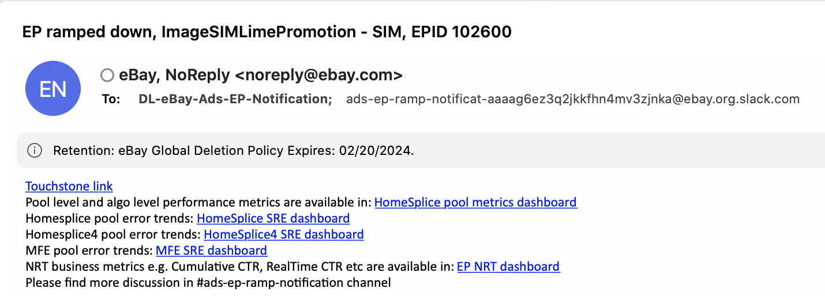

# Aug 18, 2022

Clark

Tracking - ​​[AAFF 101] Kill Switch - TDOs are able to stop a FF/EE and get the owner's phone number for Site incidents

​​<https://jirap.corp.ebay.com/browse/RELEASE-120742>

[User Center & ACL Design Proposal](https://docs.google.com/document/d/1IRYoJ_UQ7bawNk2zQJD1iK_rffc_gs3ze-L1JJg37WY/edit#heading=h.clkh5l2bkl4g)

Hancheng

1.Completed data quality verification on one day sum of count between madcdl results and ES results based on xt tag.

​​<https://docs.google.com/spreadsheets/d/1EJOgR1yRN5gT7qg3ZXNpxdrup55T5xp6g4WIZ53LAdk/edit#gid=0>

<https://docs.google.com/spreadsheets/d/1jn-TWM_Uhr0QXRrAWcf_J9NdxeV8dV02RBhUf0MymDg/edit#gid=0>

The median difference ratio is 1%~2%, discussed with domain QEs and have high confidence on data quality to provide to PM for real-time monitoring.

2. Local developed NRT page in order to onboard new data resources to the control center.

1. Expand EPs to PageOptimization, plmts, HP etc
2. Support select ep by EP type
3. Support retrieving data through both XT and ET tags.
4. Support real-time time step selection from 5m -> 1h -> 1d

See attached screenshots below.

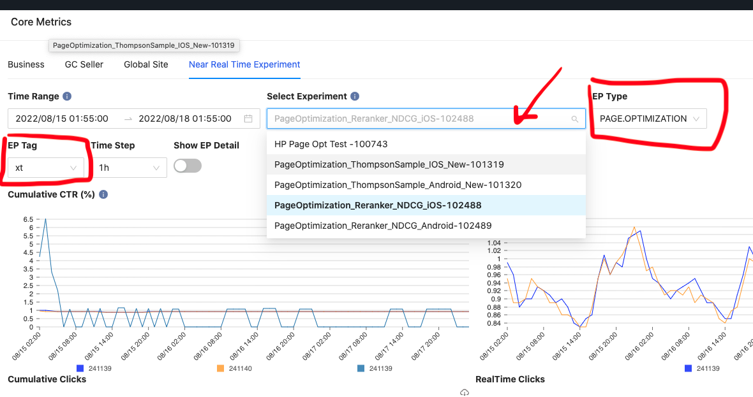

Xiaoyue

# Aug 11, 2022

**Slack Updates**

Xiaoyue:

EP factor validation notification email

* From Zhangyu: so when it is on auto mode, ie when EP owner finishes setting up an EP , it will auto validate the factors and send out the notification no matter it fails or passes

Hancheng:

* manipulated MADCDL query and run in zeta to get both click & impression sum, compare with data in ES index
* there are few around ~ 1% difference between ES NRT data and MADCDL data but the rates which applied to same control and test EP treatments are pretty close, e.g.

the NRT/MADCDL of plmt100721 xt240589 is 1.0125

the NRT/MADCDL of plmt100721 xt240590 is 1.0126

will continue on data collection and verification, and started working on shepherd UI to onboard new NRT metrics based on XT tag

**Previously:**

Clark - new ep info index (changes metadata)

* Moving logic from adsinfrajob to adsinfra-common

Xiaoyue - 2 email notifs: ep ramped up, ep factor validation success

Hancheng - check if there’s still duplicates next week in ctr-xt* after enhancement of rollover policy, parallelism, and 2nd mapreduce.

# Aug 4, 2022

Summary:

Clark - new ep info index (changes metadata)

Xiaoyue - 2 email notifs: ep ramped up, ep factor validation success

Hancheng - check if there’s still duplicates next week in ctr-xt* after enhancement of rollover policy, parallelism, and 2nd mapreduce.

Clark

* Separate ep info (changes metadata) in new ES index

Xiaoyue

* Email notification
  + 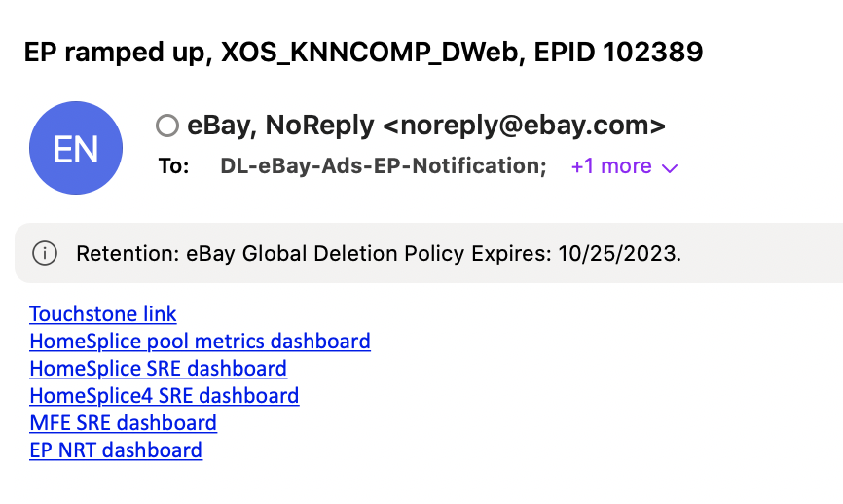
  + Update on work on John Yu to add more description to email
    - ~~We have 6 dashboard links now~~
    - + DL
    - + channel
    - Automated email
    - Suggestion:
      * Add slack channel in email
    - New content added:
      * Contact info
  + Email notifs for Ep factor validation for success
    - How about failures?
      * Can the PM see the failure right away? Yes. in Jenkins.
      * If done through touchstone UI, failure won’t be seen by the PM. need to check Jenkins
    - Algo validations?
    - Right now it is on Jenkins and on demand.
  + Do we have a ticket to track this?

Hancheng

* ~~filed request for adding Kafka capacity 30000 KB/s so I can create a new prod kafka consumer to listen from topic behavior.pulsar.customized.pl_merch_ima~~
* ~~job is successfully launched on rheos prod now~~
* ~~Created new flink job (instead of flink app)~~
* ~~Added~~ **~~et~~** ~~field in ctr-xt (ES index) (includes xt)~~
  + ~~For flink output metrics~~
  + ~~I.e. query et return 3 results, query xt return 14 results~~
* Next step:
  + IMA sharing session
  + Verify data correctness. Check with shao jing’s
  + Then, onboard the Control Center dashboard. Then get more feedback.
  + Backward compatibility and more scenarios

Issues in ES - No rollover policy :

* No rollover policy - once shard reaches threshold, it will break.
* Maintained by bandrui (ads reporting team)
* Two days ago pinged by PD? Our job had a huge writing speed and storage sized growed quickly.
* 50-100 MBs it will overload in 3 days
* Checked in esadsquality
  + Enabled rollover policy in Index Management Tool
    - When reached 150 index size and max docs 3000000000. Max age 45 days.

Issues in ES - Abnormal write speed huge daily size

There are specific task that consumes a lot of resource.

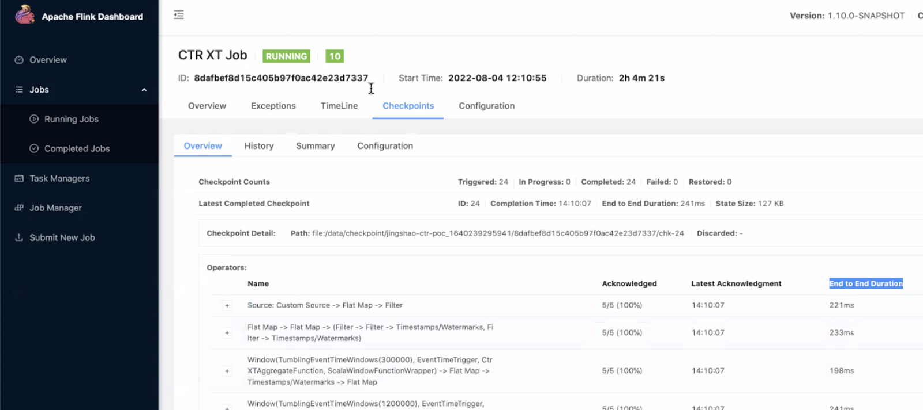

To deal with this, added parallelism

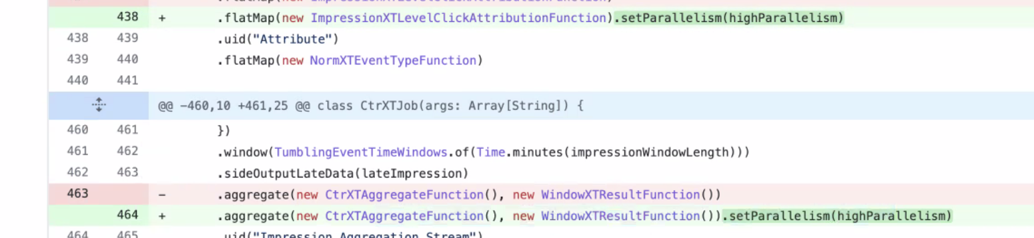

This reduced end to end duration. Previously 1 hour, now 2s.

Issue - huge data loss (ES index **ctr-xt\***)

1 hour data has 10 million hits. Reason, a lot of duplicate keys.

Duplicates on - placementid, xt, siteid

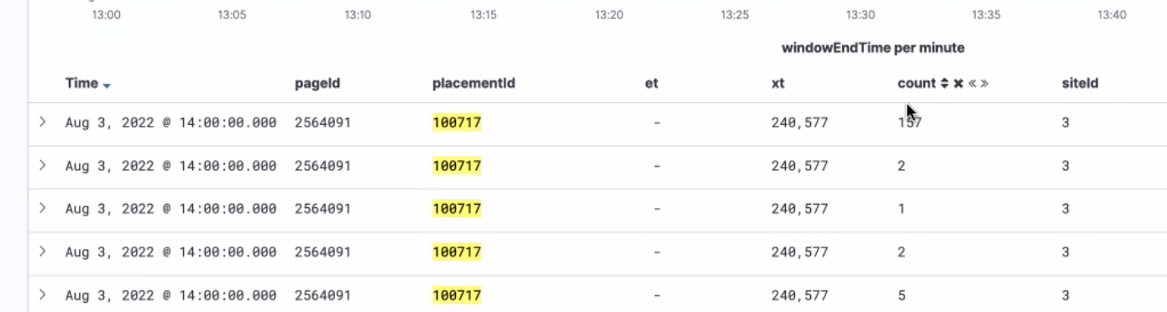

Common issue in real-time processing of flink. Data is not always constant. There will be late data. It will result in duplicates. Need to aggregate in one final result.

Previous flow

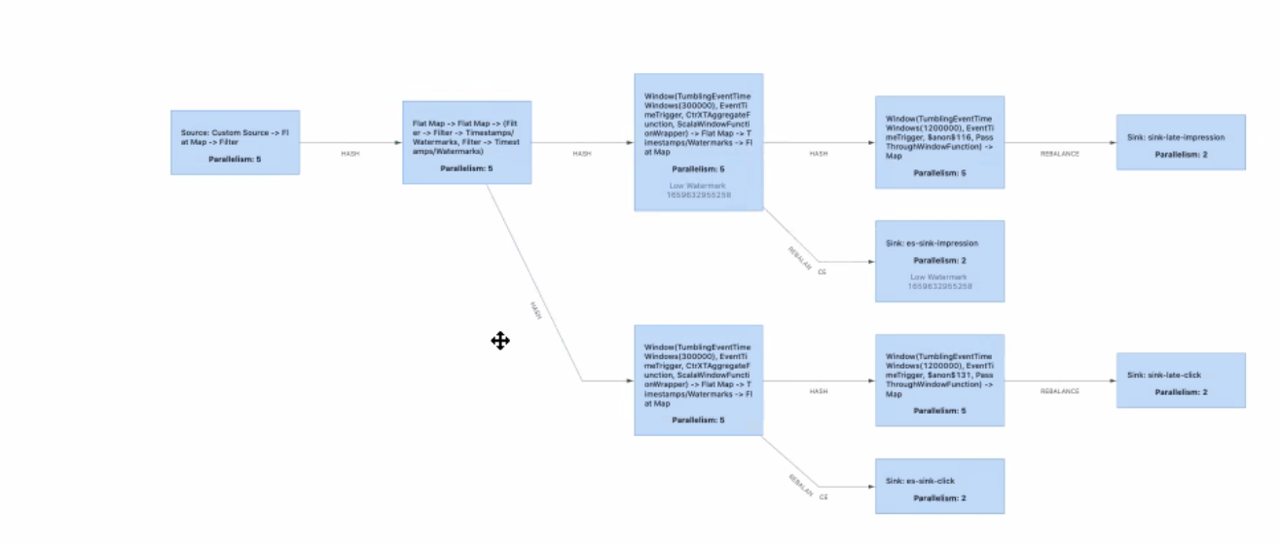

Added mapreduce for 2nd time aggregation

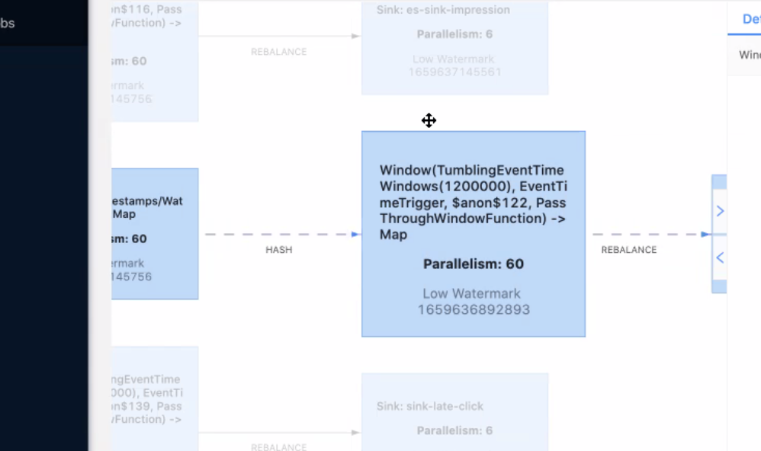

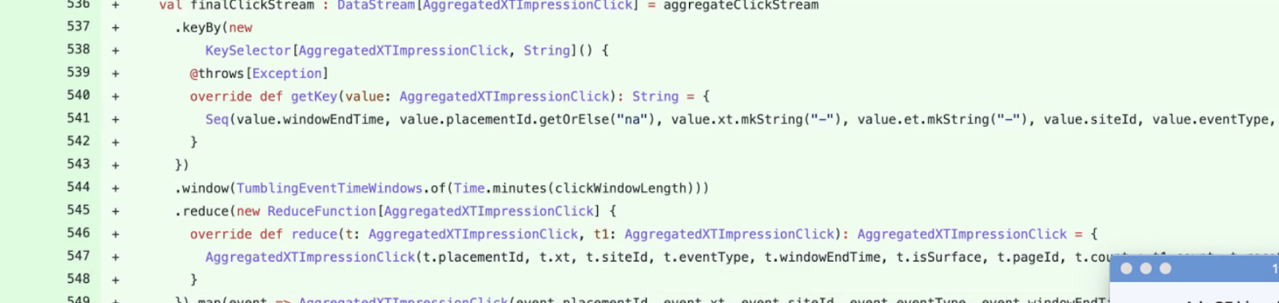

With 2nd round aggregation - now around 160k docs per 1 hour. Much better. Size from 1.5gb to 700MB. Faster query speed. Faster than shao jing’s (ES index ntr-ctr* for et tag), she didn’t have the mapreduce.

Xt tag is much larger than shao jing’s data, but we have faster query.

Roll over policy:

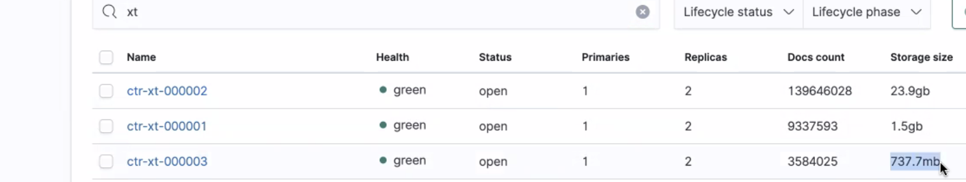

Issue rheos flink job - checkpoint save job continuously failed

Because there's a 2 days delay, check on Monday if there’s still duplicates.

% duplicates in et?

% duplicates in xt?

We have a lot of xt tag without et tag in ctr-xt*

Pending

* Treatment id to Ep id mapping. Will wait for CCOE to implement their feature.
  + <https://jirap.corp.ebay.com/browse/SHEPHERD-1365>
  + <https://wiki.vip.corp.ebay.com/display/AdsInfra/New+dimension+-+Search+EP>

Should we have our own namespace?

* ~~Will discuss~~
* Currently using the CCOE namespace
* Contains rheos job and flink jobs
* Make sure to separate money from infra (separate the tooling)
* What’s our future footprint/effort if we need our own namespace in the future? Priority?
  + If we need a new namespace and app, we need a version upgrade. (old app can run old scala version)
  + Looks like a large effort is needed if we need the latest scala version.
  + Action: create ticket - new namespace migration

# Jul 28, 2022

Xiaoyue

* Email notification
  + 
  + Update on work on John Yu to add more description to email
    - We have 6 dashboard links now
    - + DL
    - + channel
    - Automated email
    - Suggestion:
      * Add slack channel in email
  + Do we have a ticket to track this?

Hancheng

* ~~filed request for adding Kafka capacity 30000 KB/s so I can create a new prod kafka consumer to listen from topic behavior.pulsar.customized.pl_merch_ima~~
* job is successfully launched on rheos prod now
* 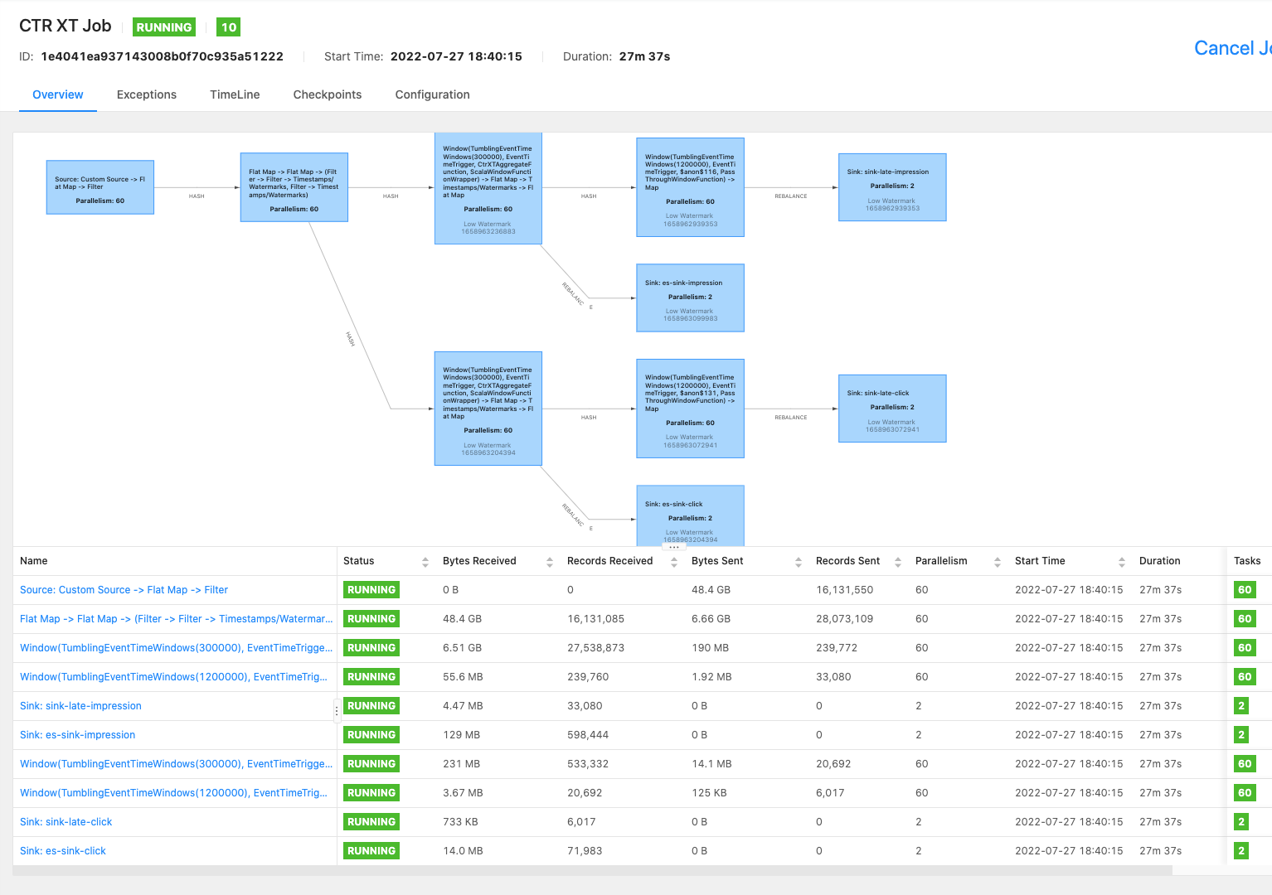
* Created new flink job (instead of flink app)
* Only supports 1.13.5-scala.2.12
* Added **et** field in ctr-xt (ES index) (includes xt)
  + For flink output metrics
  + 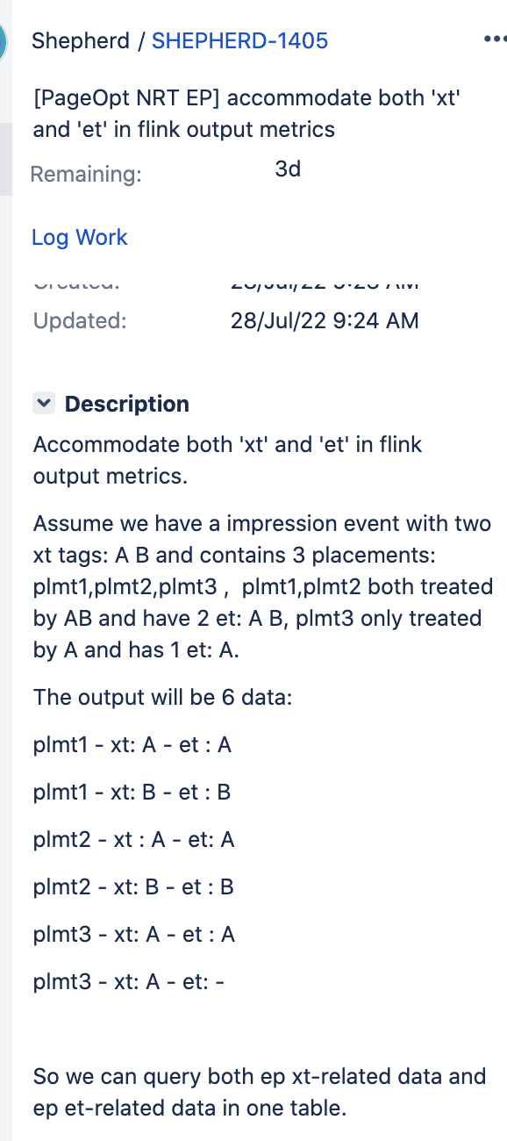
  + I.e. query et return 3 results, query xt return 14 results
* Next step:
  + IMA sharing session
  + Verify data correctness. Check with shao jing’s
  + Then, onboard the Control Center dashboard. Then get more feedback.
  + Backward compatibility and more scenarios

Pending

* Treatment id to Ep id mapping. Will wait for CCOE to implement their feature.
  + <https://jirap.corp.ebay.com/browse/SHEPHERD-1365>
  + <https://wiki.vip.corp.ebay.com/display/AdsInfra/New+dimension+-+Search+EP>

Should we have our own namespace?

* ~~Will discuss~~
* Currently using the CCOE namespace
* Contains rheos job and flink jobs
* Make sure to separate money from infra (separate the tooling)
* What’s our future footprint/effort if we need our own namespace in the future? Priority?
  + If we need a new namespace and app, we need a version upgrade. (old app can run old scala version)
  + Looks like a large effort is needed if we need the latest scala version.
  + Action: create ticket - new namespace migration

Is ES debug_xt aggregated? Yes. Partial aggregation every 5 mins.

* ~~Maybe need a non-aggregate to monitor and alert?~~

# Jul 21, 2022

Treatment id to Ep id mapping. Will wait for CCOE to implement their feature.

* <https://jirap.corp.ebay.com/browse/SHEPHERD-1365>
* <https://wiki.vip.corp.ebay.com/display/AdsInfra/New+dimension+-+Search+EP>
* 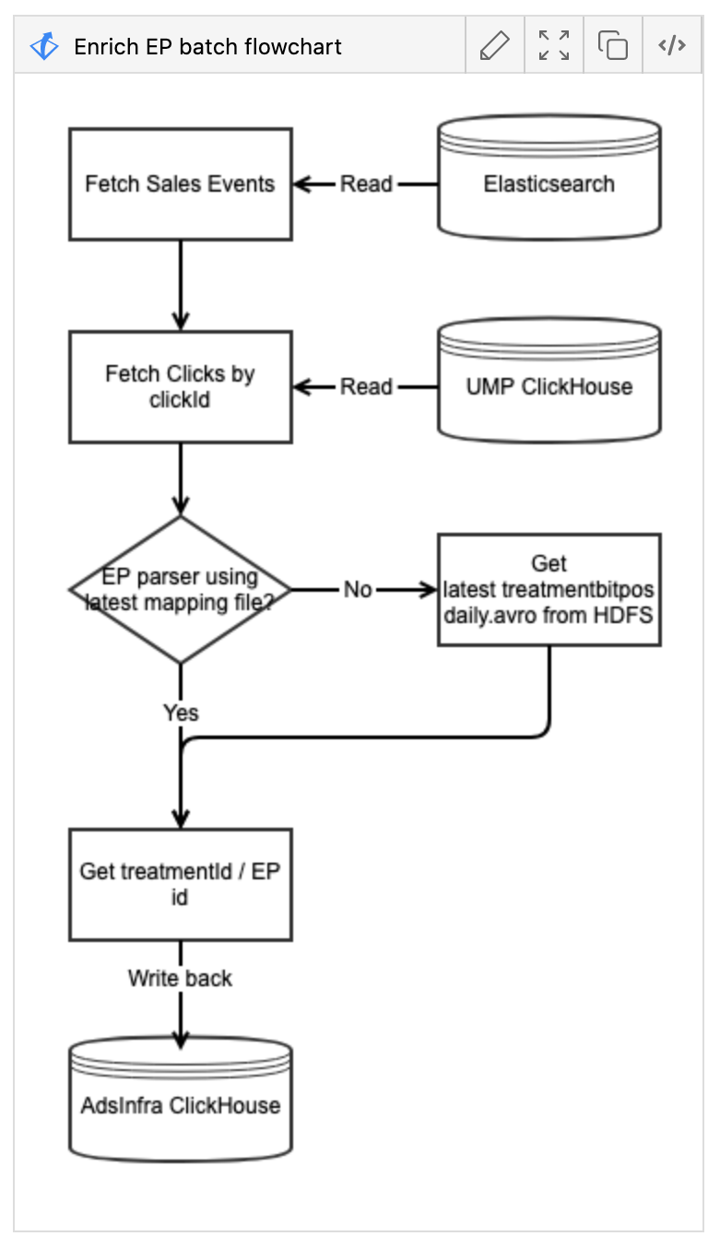
* Work may only cover Search. And this is only treatment id and ep id only.
* Honghao and pavel will discuss

Xiaoyue

* Email notif sent to this slack #ads-ep-ramp-notification <https://ebay-eng.slack.com/archives/C03Q0F28Y85>
* 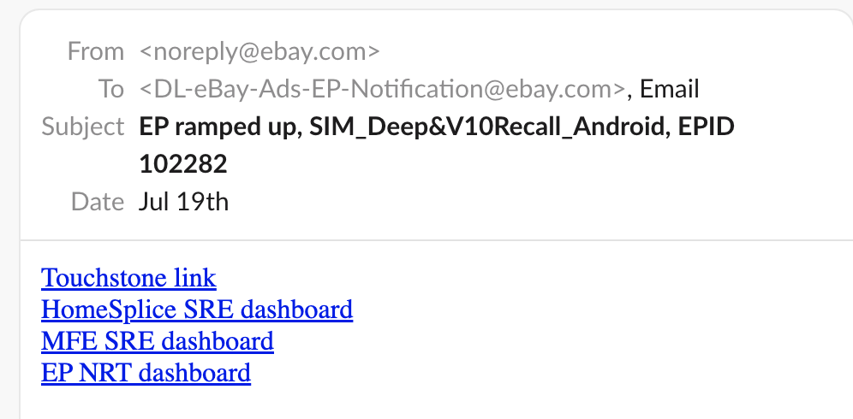
* Will work with john yu to add more description, or which one to click and why. Google docs for more info.

Hancheng

* Test rheos flinkjob done in staging
  + Started EP in staging and was able to capture click events
  + Recorded to staging ES debug_xt
    - Merch impression
    - Added click attribution
    - 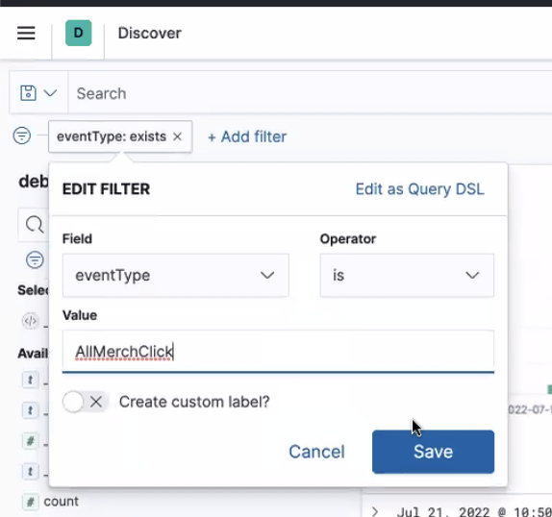
* Next step will onboard to production environment
  + Notes: EP traffic is huge. Will need lots of space and CPU
    - Shaojing flinkjob borrowed resources in pl-express
  + Hancheng filed capacity request
    - <https://jirap.corp.ebay.com/browse/RHS-12574>
    - Need to add capacity estimate. Check with Shaojing’s borrowed pl-express capacity
      * Job Manager: 2
      * Task Manager: 22
    - Who to contact to expedite?
      * Dawei will follow up with Zhong, Chonglin (She/Her). Name in jira ticket
  + Issues in flinpo
    - Issue 1 build maven package
      * Previous code had a different maven command. Because they added extra things
      * Updated code base to fix this
    - Issue 2
      * Connect the kafka service just used config and authentication, which needs SSH key and password from rheos. However, shaojing’s job does it differently using “trust”.
    - Hancheng forked flinpo and using it in local
      * Where will deploy the consumer and namespace?
        + Rheos: ebay-bandrui-pd-for-migration1

CCOE Instrument all click events and data to monitor. Will request another namespace for this.

Should we have our own namespace?

* Will discuss
* Currently using the CCOE namespace.
* Contains rheos job and flink jobs
* Need to separate money from infra (separate the tooling)

To hancheng, do we have metrics for clicks that are missed?

* Hard to figure out/capture
* Jingshao logs production data with specific id and madcdl and check if there is a gap or not
* We have 10 mins window for impression id is there
* Flink has a way to process late data for late impression and late click
* Get metrics:
  + % of late data.
  + How many missed?

eventType: AllMerchClick

* Query placement id and xt tag
* No need to check if late or not.

Is ES debug_xt aggregated? Yes.

* Maybe need a non-aggregate to monitor and alert?

# Jul 14, 2022

Email notif tested - OK

* Will see emails soon
* ~~Need kibana access for hancheng~~

All clicks includes organic, PL

We need a longer time period such as 30 days.

# Jul 7, 2022

Email Notification from John Yu. to discuss tomorrow.

We don’t drop xt tag events for all merch EPs.

Xt tags related to VI EP and not merch EP

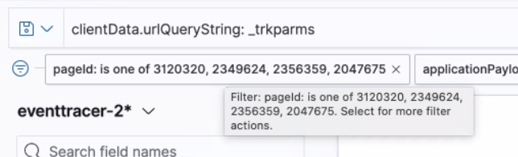

Attribute click to impression with certain time window. Flinpo, collect click and impression with a map.

After we get clicks, we look for “me” id

Status: Get all active ads related EP

* Asked EP team if they have endpoint for this.
* <https://touchstone-api.vip.ebay.com:8080/api/v1/tsexperiments>
  + completedStatus
* Currently looking at this endpoint: <https://touchstone-api.vip.ebay.com:8080/api/v1/exptactiondate?startDate=2022-04-07&endDate=>
* Other endpoints looked at:
  + <https://touchstone-api.vip.ebay.com:8080/api/v1/traffic_monitor/job?alive=true>
  + <https://touchstone-api.vip.ebay.com:8080/api/v1/tsexperiments?start=2022-04-07>

# Jun 30, 2022

Maybe end of July for feature

* Maybe use RCG to build features

Dawei create slack channel

Hancheng - leverage on NRT

Honghao - requirements are good

Check with treatment if control or test

Treatment id -> EP id -> treatment

Page - EP tab, Treatment tab

Table of active EPs (ads related)

* Primary id: EP + treatment id
* Epid->treatmentid mapping and treatmentid->EP mapping
* Touchstone API for treatment id [Hancheng Xiao](mailto:hanxiao@ebay.com)
  + <https://touchstone-api.vip.ebay.com:8080/api/v1/experiment/search?treatmentId=238482&start=2022-05-04&end=2022-05-11>

Hancheng local data

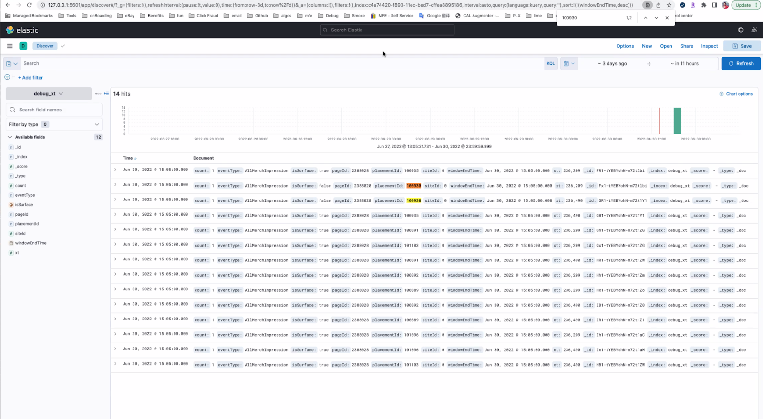

Reco

One id one et tag

Other id has two et

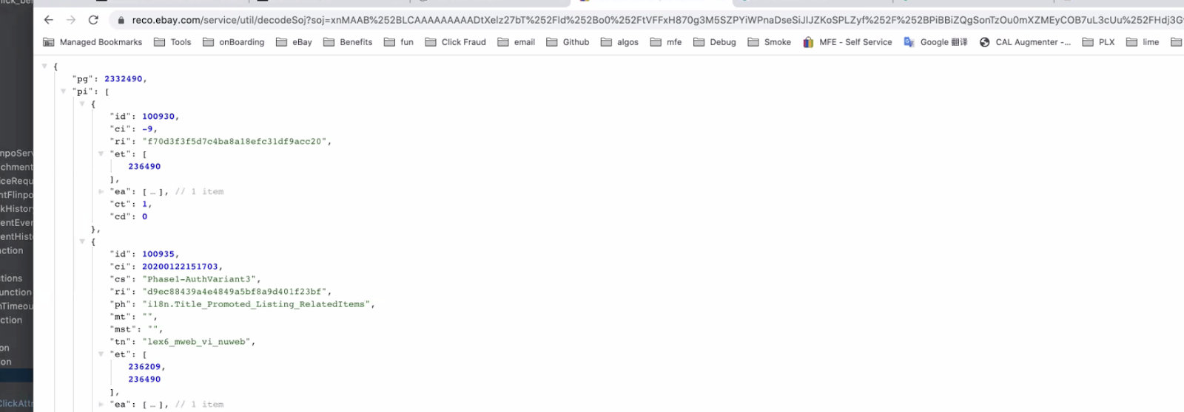

Ctr

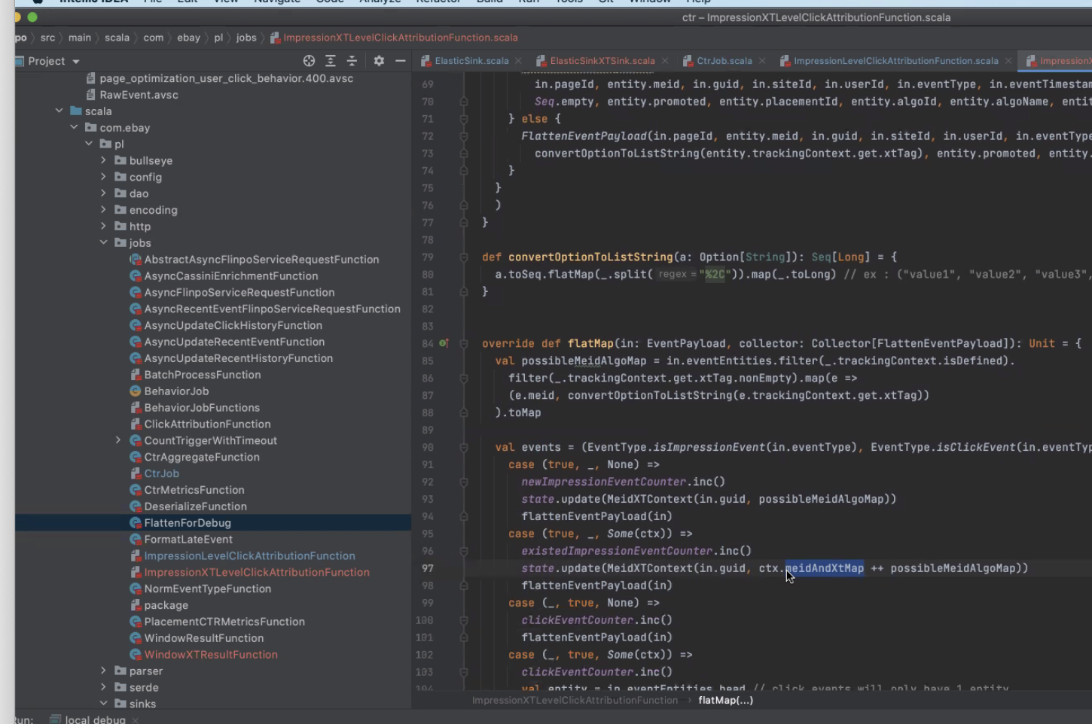

CCOE main source of data

Sellerhub and clickhouse

Raw impression events are too much. They put it in Rheos v2 topics with 4 fields.

Need url deserialization here

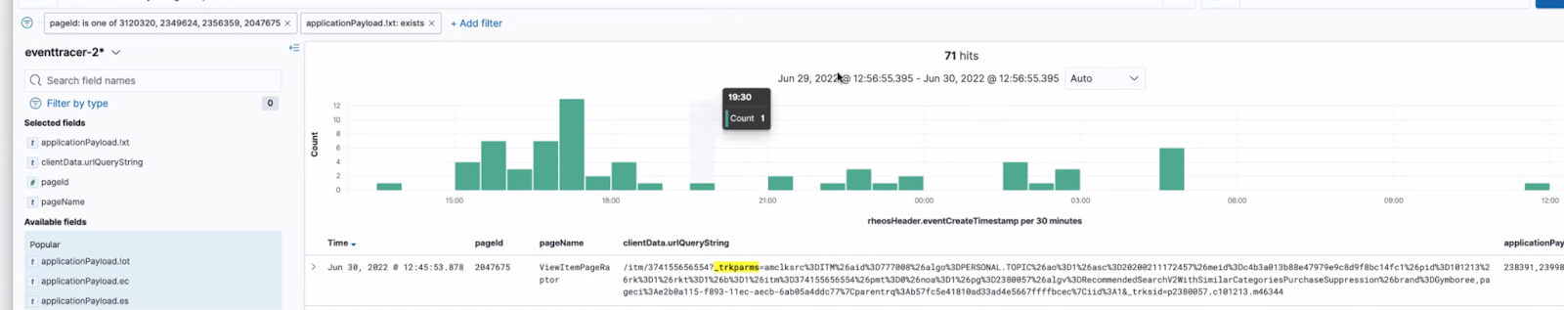

# Jun 23, 2022

Meeting with John Yu, Prajakta, Xiaoyue on how to get rheos

<https://docs.google.com/document/d/1D-Tbv1PKYe7w2oY-WeGjwmVs0xKRXwP_F16jsKtX_co/edit#>

Rheos Events to Metrics

What’s our next step?

Replace touchstone with real-time

We need to convince the business

PD team needs to confirm that’s what they want

Just get additional input from PM and PD

We can get Josh. from analytics.

Rheos is for pageopt

Dawei will ask to PDs

Hancheng

* code/debug use of xt tags in rheos events - still in progress

Xiaoyue

* [maybe not needed] touchstone email notification enhancement
* [not needed] check on servedTraffic calculation with EP team
* Backup plan to talk to John Yu to retrieve all active EP, then send as email

# Jun 17, 2022

Action items update:

Hancheng - code/debug use of xt tags in rheos events - still in progress

Xiaoyue

* survey to PM for metrics. - worked with Dawei.
* touchstone email notification enhance to include dashboard and JIRA links, etc. - check with EP customer meeting
  + Followed up with Kalin (TS team) and provided details (feature request ticket created)
  + No timeline yet
  + Before TS can be implemented, we can look at Jenkins job. - check with Zhangyu/Dawei
    - EP id -> pool -> jenkins
      * Check the delta of the newly launched
* check on servedTraffic calculation with EP team - in progress

# 

# Jun 9, 2022

**Safely use in xt tag? Yes**

**Praj she clearly mention, we should use xt tag for pageopt**

**Different placement always have different algo**

**pageopt is on top of algo variance**

**Desktop uses Thomson sampler**

**Orthogonal EP?**

**Two planes. no conflict to each other.**

**1 PO running on 1 channel**

**But for algo targeting there could be multiple POs**

**We support multiple POs**

**PA PD PO**

**7 placement**

**PO would be 70 impressions**

**Each placement has 1, each page id has 1 with the dimensions**

**Everything we needed to count as number, we needed to count impressions. For this EP, for this placement, for page id, how many impressions?**

**Same for click, then we can do CTR**

**We want to verify if PM uses the same logic**

**Honghao:**

**Write down the model or equation**

**Xiaoyue:**

**Look at placement level impression instead of item level. They look at touchstone support metrics and Control Center as well**

**Gather feedback thru a survey. Find the major metrics they look at. Show a demo with basic info (then just add more dimesions) and get a feedback.**

**Send out notification email for VPs. Currently, touchstone send emails like pause, smoke, EP complete. But they don’t have require details like dashboard links and JIRA links.**

**We already listen to CRs in CC. If data collection stage, and EP start, if 1% (smoke) then we can signal start of EP. we can send a list to EP owners with customized body of the email.**

**Issue that we face: the traffic of CR is pretty confusing.**

**1st approach - Do we enhance existing TS emails? Maybe ask in EP customer meeting.**

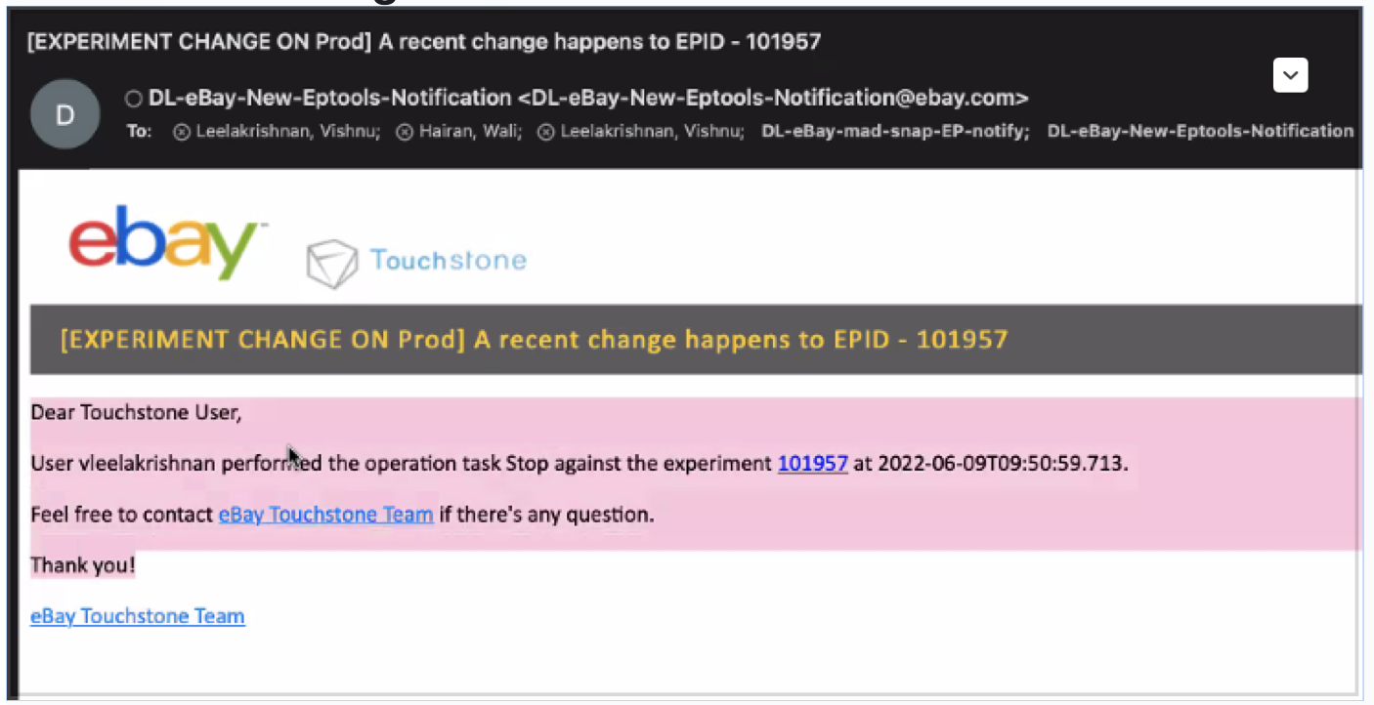

**2nd approach - Or create new email notifications? Using Control Center - react to CR when generated right away. Honghao wanted to do this before, like listen to SNOW events (maybe meet with SNOW team and ask like publisher APIs like start at).**

**Real-time event when PM start EP in TS.**

**Can we query SNOW? Like last 5 minutes change?**

**101616 CRs**

**CHG121630060 - why traffic is 1.99%. We are not sure for the calculation**

**We opened a thread with TS team, they mentioned that they have a formula for servedTraffic calculation.**

# June 2, 2022

Action: Check what PMs look at the metrics in touchstone - dawei would schedule a meeting

Safe to use the xt tag for top level

Touchstone from PM setup. Metrics is setup from placement level and page level CRT. not a large combination to explore which is good news.

From impression rheos, xt tag from top level. Should we ignore et tag? Or go look into it.

Do we have a case where top level xt tag pageOpt and still have et tag at the placement level? I think they both exists

What if top level it indicates xt says pageOpt, then each placement has et tag.

Safe to use top level xt tag.

Rheos -> if pageOpt -> unfold sub-placement -> then apply impression number + placement id.

Build a table with 5 columns for impressions

Similar with clicks

Two separate index

* Because xt tag and et tag may mix together
* First check xt, if pageOpt, write to ES, keep algo no change. Highly suspect to EPs mix together.

List of xt tag in pageOpt, then apply all logic.

# May 26, 2022

2 calculations

* What PMs and domain team need

Use case? Have alerts on EPs.

Do we have placement level impression? Maybe we can extract item level impression?

Any items we send to the frontend defines that we have the impression for it.

Items not shown but loaded in frontend, has impression.

As long as you made a call, even if the connection got lost, it will still count as impression.

Current CTR - binary metrics

Example 10 items, purchase 5 items, you purchase 2 = 7. 7.7

No matter how many you buy, it counts as one.

If we are referring to item leave impression with xt tag outside, we don’t know what item is affected with xt

We want item level impression, what is the right info to get that.

We will use et tag

PO is just another EP

Whatever placement the treatment touches, et will be shown.

Pageopt team recommends using xt tag and not et tag for NRT page - Xin Yin

xt is more accurate

If we want to get per item impressions, what is the right way?

What is not reliable for et tag?

<https://ebay-eng.slack.com/archives/CTZBF7LTU/p1645718716668189>

Note: every team defines impression differently

We follow analytics team for impression definition and that's what we support for customers as well

Et vs xt

<https://wiki.vip.corp.ebay.com/pages/viewpage.action?pageId=873072778>

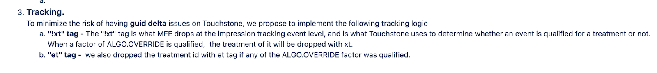

Et tag

Id is placement id

ii - input item

oi - output item

How many item recommendations?

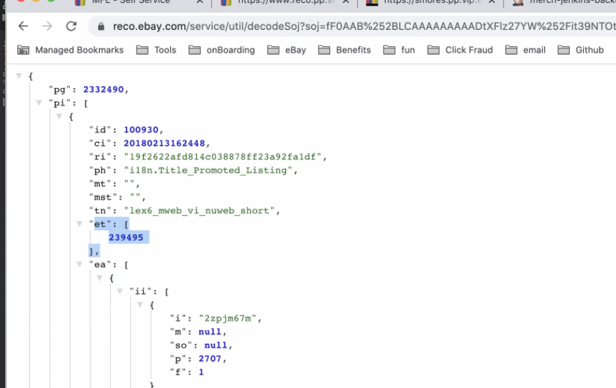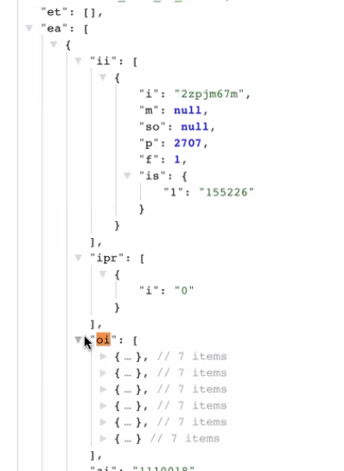

Xt and et are both treatment ids

Algo Targeting and PageOpt can provide xt tag

Rheos topic



Network tab -> getSampleData -> response -> check for xt

Check xt with corresponding treatment id in touchstone to check if its pageopt



Merch MFE has 3 different pageIds

* Because we have different endpoints for MFE (legacy, rover, etc.)
  + 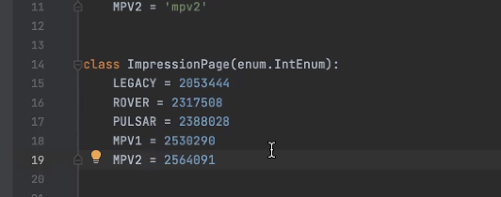

Decode souj data to get et tag

# May 19, 2022

action item:

Xiaoyue - check what metrics are important then check if those metrics are/can be supported

Hancheng - [done] meeting with Praj and include Honghao and Clark

need to think how a troubleshooter/on-call would use EP time series.

1st level - Core metrics page: improved annotations for EP to show traffic level and start and end date for EP phase instead of manually checking each annotation

2nd level (domain team) - separate page for EP time series to deep dive.

Discussion on EP time series in Business page vs separate page

* Business page
  + Placement traffic is already here
  + 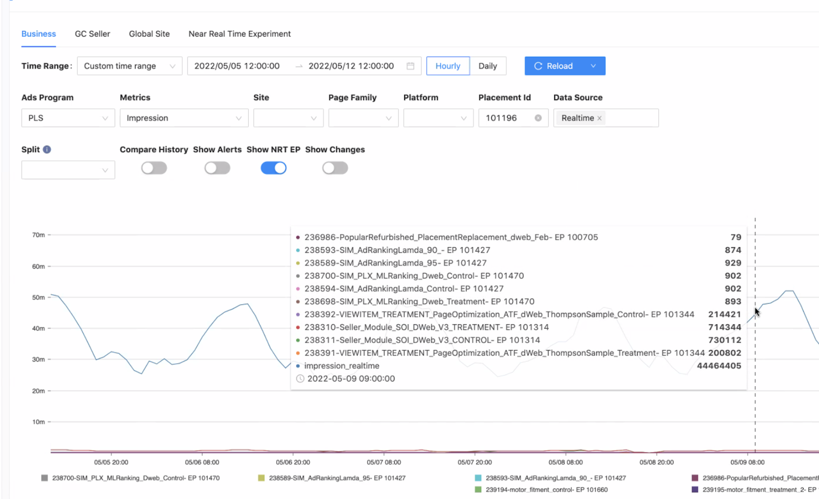

Who will maintain NRT?

Dawei - what are the blocking for PageOpt?

* Hancheng: don’t know how to retrieve xt

Xiaoyue - check what metrics are important

Hancheng - topic id and page id

Honghao - sync up with Praj to understand end-to-end

This is not a raw topic. This is topic on topic. Topic that generates new topic. A filtered filter topic

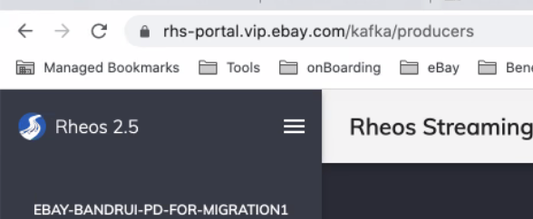

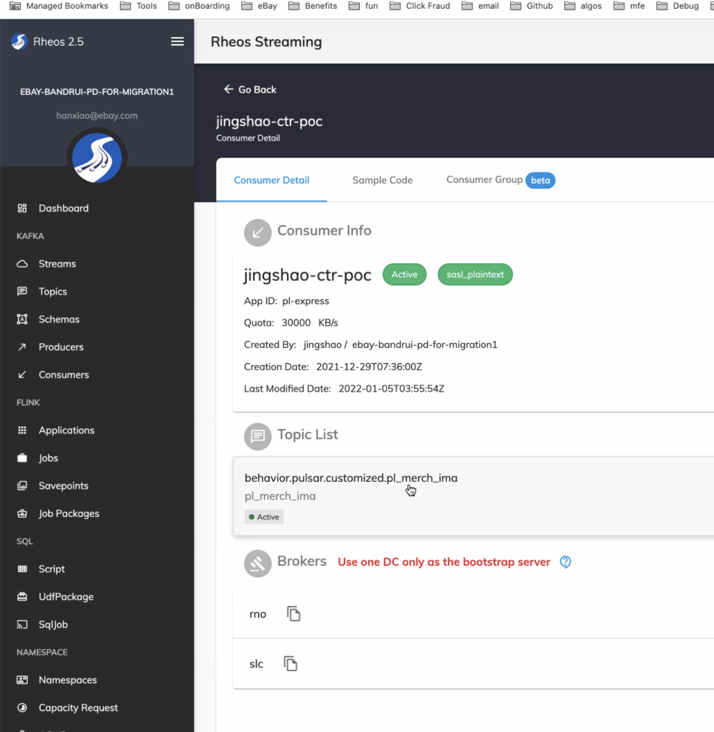

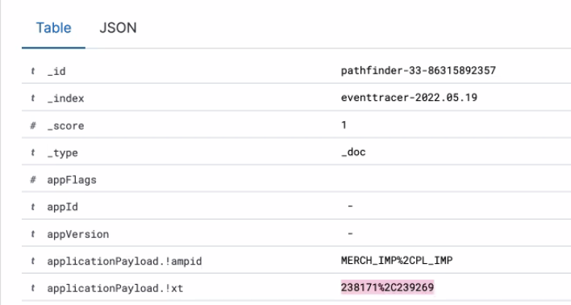

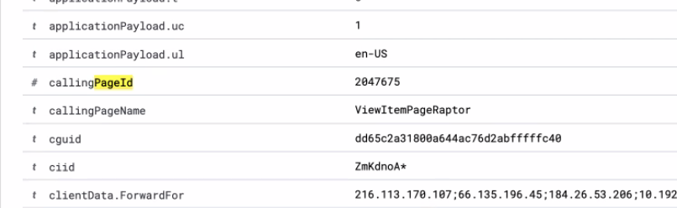

# May 12, 2022

Action item:

* Create ticket to add requirement for UV for seller-side EP

Hancheng update - show existing treatment ids given placement id

<https://touchstone-api.vip.ebay.com:8080/api/v1/experiment/search?factorValue=101196&start=2022-05-04&end=2022-05-11>

* If we don’t see the treatment id in future, it means it is completed.
* FYI. the time range for each treatment id is there, it's just that the data difference from the total is big.
* Suggestion from XIaoyue:
  + link to redirect for more info
  + Add more info such as what EP belongs to the treatment id

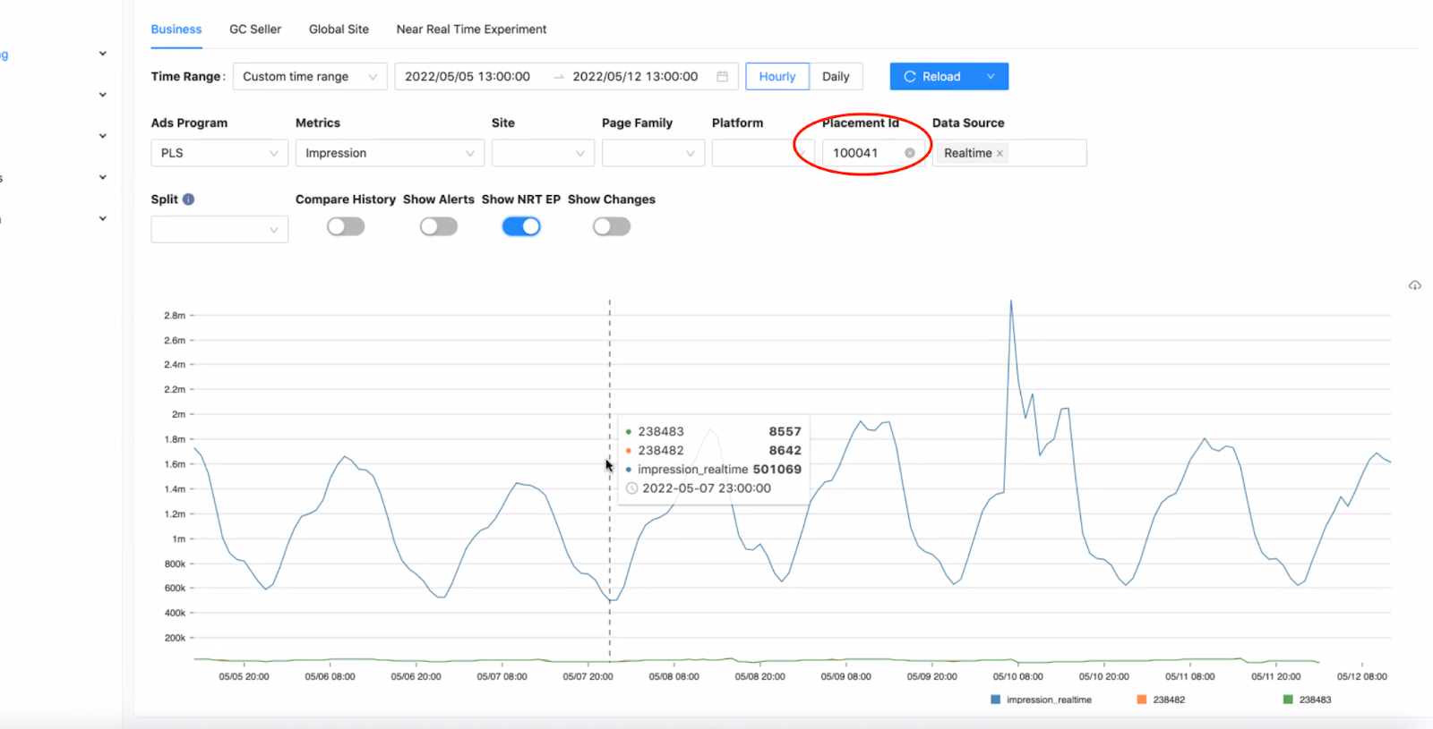

Clark:

* + [done - production] adsmetadatasvc Experiment Info API
    - show EP history (served traffic): /history/{id} <https://adsmetadatasvc.vip.lvs.ebay.com/adsinfra/v1/epinfo/history/101618>
    - show general EP info: /{id}
      * <https://adsmetadatasvc.vip.lvs.ebay.com/adsinfra/v1/epinfo/101618>
    - show general EP raw data: /{id}&infer=true
      * <https://adsmetadatasvc.vip.lvs.ebay.com/adsinfra/v1/epinfo/101618&infer=true>

# Meeting 5/5

UV to join next week meeting

Ganesh:

SELLING SIDE

Ads Experiment Framework - A/B Testing for Seller Side:

<https://docs.google.com/file/d/1UpAF1ZmEWNlRCa1cWlYASm-ihokMH_OZ/edit?filetype=msword>

Internal tool for now.

Lead: UV (Uvaraj)

Major metrics detail

Real-time metrics

Elasticsearch index

Spark job is not so real-time

Timeline? End of Q2? In Touchstone?

# Meeting 4/28

Given EP id

* Metrics id and names

API 1

Infer = true

* Raw plus info

API 2

Ep history

* Summarized history

<https://github.corp.ebay.com/adsinfra/infrarepo>

Action item:

Dawei - Link for EP scheduling and calendar

go/merchab

Personal management google sheets

# Meeting 4/21

| 2022 Q2 | As a user, I can view   * **[done]** EP audit logs (EP history) * EP time series for served traffic percentage * [won’t work on - NRT jing shao] EP conclusion (hypothesis met or not, launch decision, email) * EP scheduling and calendar (tentative)   As a user, I can filter EP based on algo targeting and page optimization  As a user, I can onboard queries from MADCDL (Table)  (New user stories will be added when we receive new requirements from showing our proof of concepts to stakeholders) |
| --- | --- |

Historical EP now available

* Start time
* End time
* Status
* Action type
* Served traffic percentage

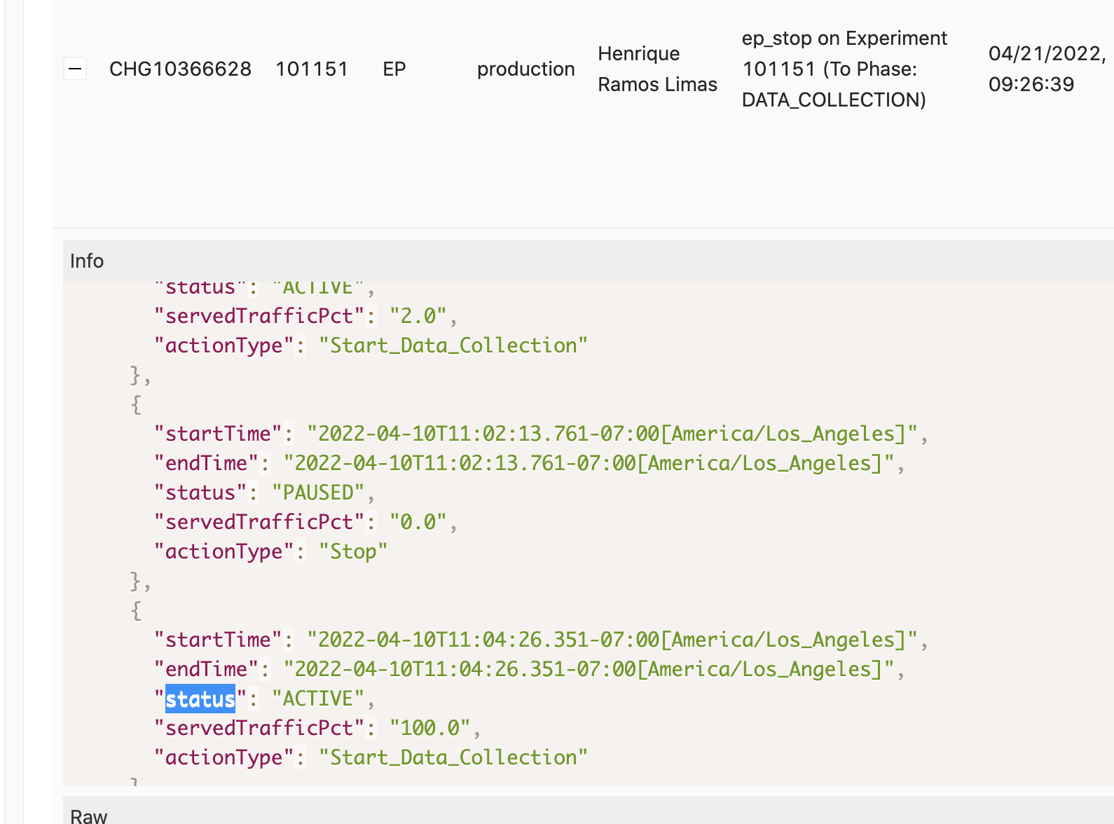

Data Collection is a manual trigger

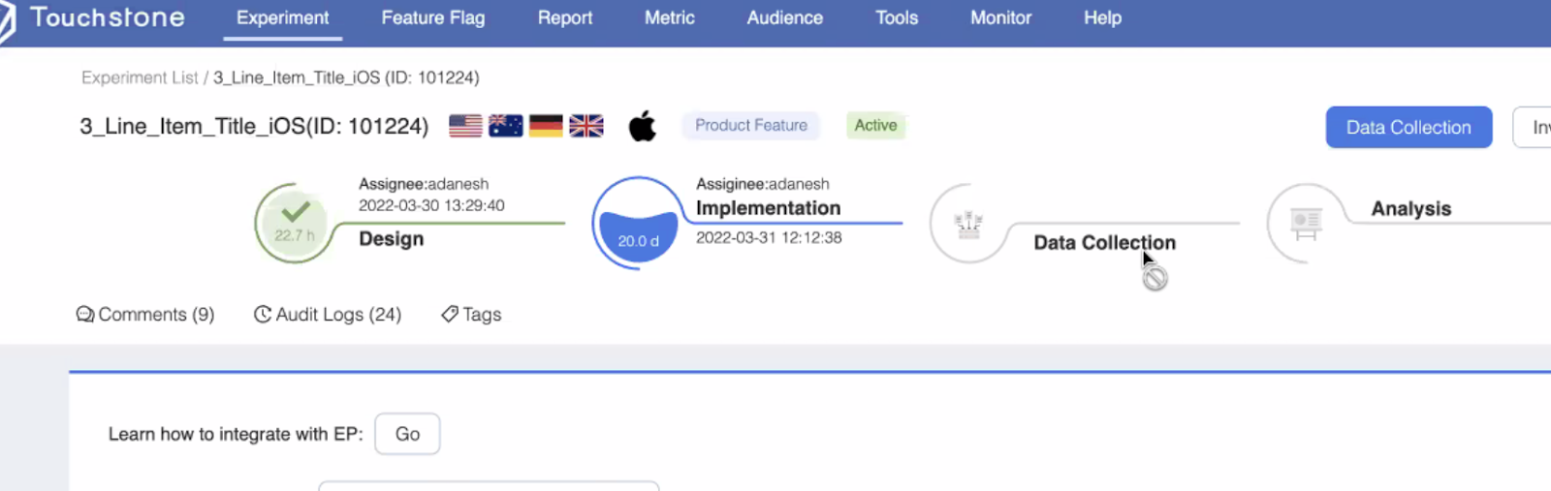

Start and end date for tsexperiment API (touchstone)

<https://touchstone-api.vip.ebay.com:8080/api/v1/tsexperiments?start=2022-04-14&end=2022-04-21>

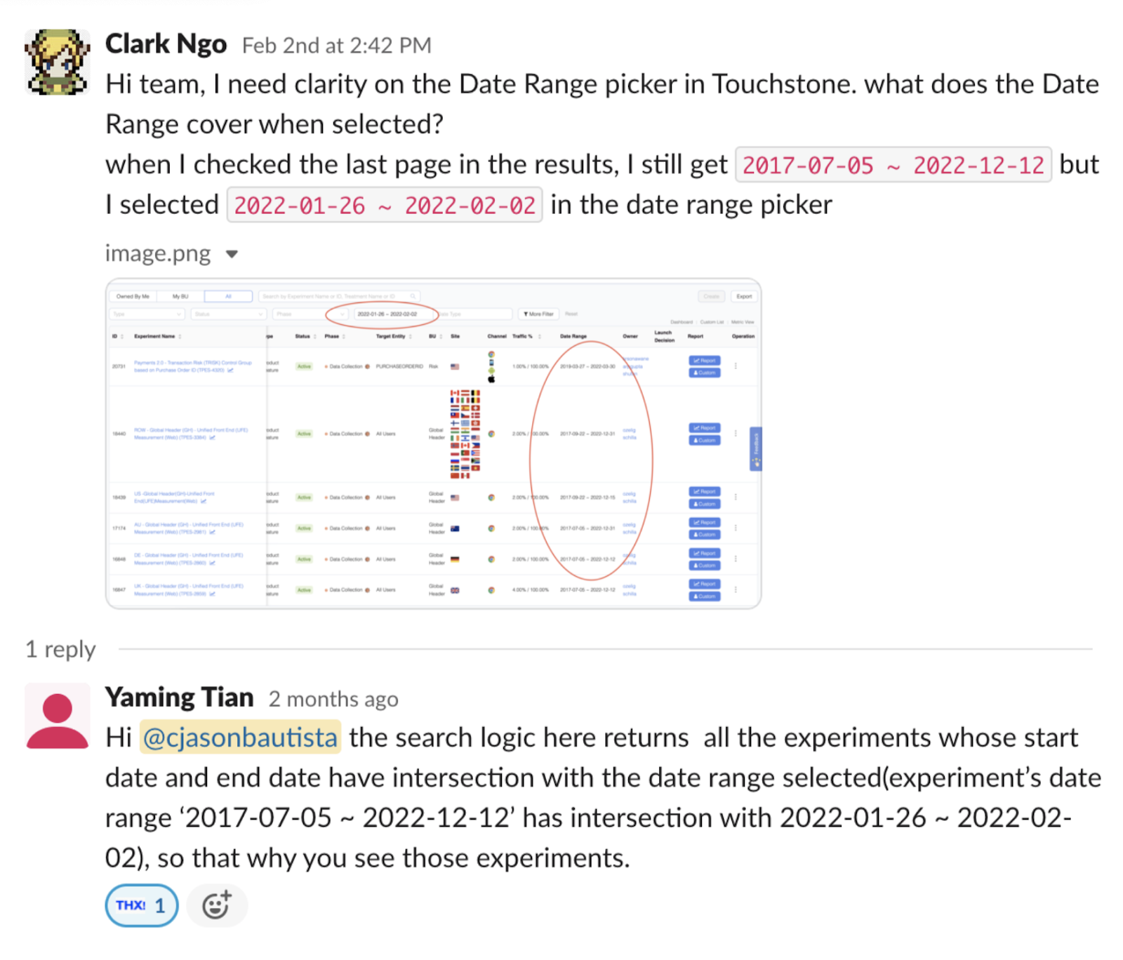

# Meeting 4/14

Clark

* EP data is now back filled
* Added historical served traffic data
* API design for EP backend server

Xiaoyue

* Evaluate EP info in CC

# Meeting 4/7

Slack Thread

​​question: et vs xt tags? can I have a summary in words?

question: traffic % vs target entity %?

Hancheng Xiao

answer to question 1:

et tag is from mfe placement level soj impression. xt tag is from application Payload.!xt of whole mfe call.

A mfe call may contains multiple calls to different placements.

ET tag is on placement level while XT tag is a parent set of et tags here.

@pramore please correct me if I am wrong ^

question: traffic % vs target entity %?

Hancheng Xiao

According to changchen, if the mfe call enters PageOpt, a single plmt may or may not be executed by PO, which also result the et may or may not be dropped. That's why po team prefers using xt tag for analysis purpose because touchstone is focus on the traffic over all events.

And Changchen confirmed for analyzing one specific plmt which is exactly executed by PO, we can use et for reference. So for EP time series chart I will leverage the et events data.

Hancheng

* Jing Shao has granted us the access to <http://go/rheos-portal> you can check the topic and our nrt consumer in it
* ​​nrt-ctr index et tag
* Show NRT in Core Metrics
* Placement 100041
  + Impressions, Clicks, CTR
  + NRT with CTR with more than 1% means its wrong
  + pageOpt NRT convo with PD
    - Et can be referenced for placement id
    - Xt cannot be referenced for placement id
* Poplex engine determines which of the replacementPlan will be replaced or not

Clark

* Missing EPs due to adssrejob being blocked by touchstone

Xiaoyue

* Onboard query if allowed. Check code base.

For every request, xt request will always drop. Et and ep may not.

Et comes from sojourner impression

Each rLogId is associated with a placement id that may or may not have EP

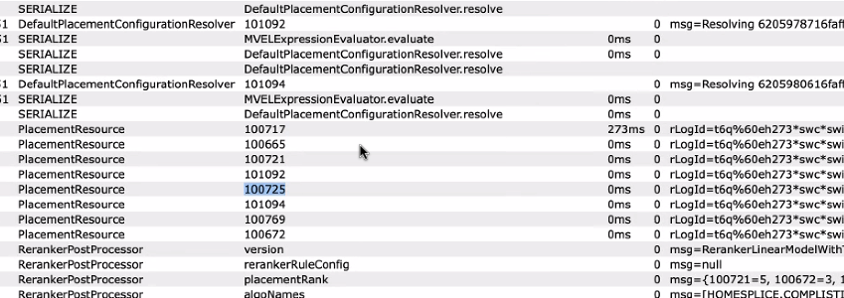

Et - we can see flow in diff placements - maybe good enough for PO

Xt - we can only see treatment and control they have same traffic, will drop xt tag

Sum of et events is not equal to sum of xt events

Start onboard PO whether Et or Xt.

# Meeting 3/31

## Action item

Xiaoyue

* Provide EP samples for diff factor name for algo targeting and page optimization

Hancheng

* Leverage Shao, Jing’s NRTs. Handle Xt tag. To provide real-time data for page optimization

Clark

* Create doc for Weiyu for Q1 done and Q2 plan.
  + User stories
  + EP metadata index: [change_info_metadata_*](https://esadsquality-kibanaslc.vip.ebay.com/app/discover#/?_g=(filters:!(),refreshInterval:(pause:!t,value:0),time:(from:now-1y,to:now))&_a=(columns:!(_source),filters:!(),index:'23f94d00-214a-11ec-9a71-19eb6bfa8bcd',interval:auto,query:(language:kuery,query:''),sort:!()))
    - ServiceNow CR data
    - EP data
      * Served traffic
      * Algo targeting - homesplice
      * Channels
      * Sites
    - As of 3/18 onwards, multiple CRs for EP ramp up/down (may have impact) instead of EP creation (no impact). Due to policy change to align with SEC on CRs for possible site impact.

## Minutes of Meeting

Clark: useful links?

Homesplice

* + <https://homesplice.vip.ebay.com/api/v1/catalog.html>
  + <https://homesplice.vip.ebay.com/api/v1/catalog>

Variant

* + **Feature -** [**https://homesplice.vip.ebay.com/api/v1/curated/listings/feature/AppleAirPods**](https://homesplice.vip.ebay.com/api/v1/curated/listings/feature/AppleAirPods)
  + **Config -** [**https://homesplice.vip.ebay.com/api/v1/curated/listings/config/AppleAirPods**](https://homesplice.vip.ebay.com/api/v1/curated/listings/config/AppleAirPods)
  + Dot Graph - <https://homesplice.vip.ebay.com/api/v1/curated/listings/dot/AppleAirPods>

Praj/Xiaoyue: PO factor name will always have PAGE.OPTIMIZATION and algo targeting have ALGO.OVERRIDE or plmt-

Hancheng: Et is not reliable for tracking the result.

Praj: Whenever you apply page opt, it is not targeted to specific placement.

# Meeting 3/24

## Action item

Hancheng

* check codebase/jingshao on surfaced vs delivered impressions
* Investigate how PO tracking works - check with prajakta more

Xiaoyue

* Show query on Zeta

## Minutes of Meeting

Work on Jing’s code, translate the query to whatever its being used now. Dong’s query with Zeta to onboard to NRT

Is the existing GUI (NRT dashboard) good enough? Or need to improve?

* Looks good for now: has treatment id, time range
* Based on the dashboard, should we be able to make conclusions?
  + Still go on touchstone (based on MADCDL) (Note: NRT is real-time)
* Dashboard gives quick look (monitor) from initial launch of EP
  + Power of test and significance of test
* Setup alerts on the dashboard?
  + Control center may not support alerts on this NRT index
  + We should have the capability of setting thresholds
* Onboard Page Opt?
  + No blocker on PO (jingshao)
  + Check with prajakta more

Onboard query?

* Might be different logic (nrt index: every 5 mins vs dong’s query - zeta: every day)
* Based on Spark, query from MADCDL
  + More focused on PTR (purchased through rate) - there’s 1 more index which jingshao doesn’t have. Can jingshao onboard that other index PTR from rheos?

CTR and PTR are important metrics

Kibana NRT dashboard: ​​

* Surfaced vs Delivered?
  + 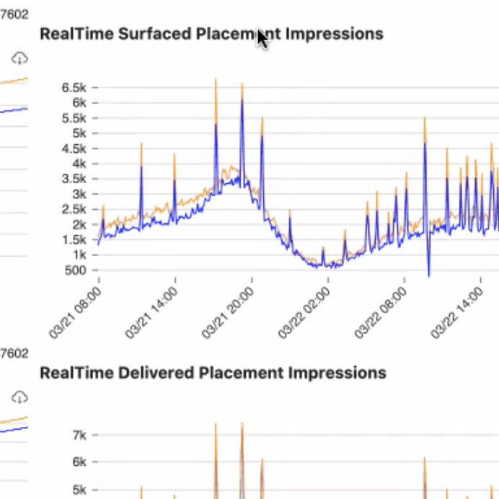
  + 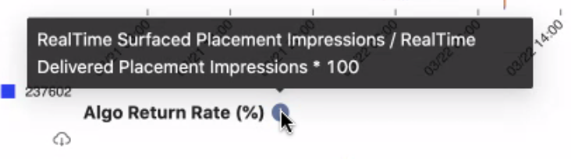
  + Surfaced - if algo surfaced or not; result returned in frontend
  + Delivered - placement called but collapsed
* Uses **nrt-ctr** index
  + <https://esqrymtr-kibanaslc.vip.ebay.com/login?next=%2Fapp%2Fkibana#/visualize>
* et: treatment id

## Updates

**Clark**

Homesplice

* + <https://homesplice.vip.ebay.com/api/v1/catalog.html>
  + <https://homesplice.vip.ebay.com/api/v1/catalog>

Variant

* + Feature - <https://homesplice.vip.ebay.com/api/v1/curated/listings/feature/AppleAirPods>
  + Config - <https://homesplice.vip.ebay.com/api/v1/curated/listings/config/AppleAirPods>
  + Dot Graph - <https://homesplice.vip.ebay.com/api/v1/curated/listings/dot/AppleAirPods>

Control Center updates

* EP info column - algo

Multiple CRs for EP ramp up/down released to prod on 3/18 (Wenjun Si)

**Hancheng**

According to Jing, the PageOpt EP will be eventually onboarded to Near Real Time ep dashboard but might not be in a short time

# Meeting 3/17

Hancheng <https://jirap.corp.ebay.com/browse/SHEPHERD-831>

Xiaoyue Zhang <https://jirap.corp.ebay.com/browse/SHEPHERD-830>

Have alerts in metrics in NRT

NRT is limited to BU:Merch and Algo-targeting (does not include Page Opt)

Check if it supports customized query (MADCDL)

Index data structure for those UIs

**Updates from Slack**

**Hancheng**

FYI this is the wiki of the pageOpt configuration system

<https://wiki.vip.corp.ebay.com/display/MADRANKING/Page+Optimization+Configuration+system>

and the PO model architechture -> 2. Two stage click / purchase ranking

<https://docs.google.com/document/d/1hChDB2OCcHYqGIbl40kW3WZwwPdOkkCUGeFCDDyvfgk/edit?usp=sharing>

Poplex will return the candidate replacement results by running ML Models as you can find in wiki/docs^

So basically we cannot tell which candidate will exactly be replaced just from EP factor

the candidate selection is dynamic

kibana link from [@jingshao](https://ebay-eng.slack.com/team/W01B6SRAM2R) <https://esqrymtr-kibanaslc.vip.ebay.com/login?next=%2Fapp%2Fkibana#/visualize>

I don't have access to it, so I submitted an access request on <https://cloud.ebay.com/pronto/case-detail/293?env=production&tab=access> and am still waiting owner for approval.

# Meeting 3/10

**Action item**

**Clark**

* Algo index
* Failed algo index

**Hancheng**

* Queryparam on show changes
* Investigate NRT on Control Center

**Backlog**

Backend API parsing EP description - shepherd

Figure out which placement id is chosen by poplex

* Page Optimization [**https://touchstone-api.vip.ebay.com:8080/api/v1/tsexperiments/98877**](https://touchstone-api.vip.ebay.com:8080/api/v1/tsexperiments/98877)

**Updates**

Clark

* [done] algo pattern

**Meeting 3/4**

**Action items**

* Add to EP info object

Info

* treatmentId
  + placementIds
  + algoFamily
  + variance

**Updates**

Xiaoyue

* [HS algo family findingsl](https://docs.google.com/spreadsheets/d/1L5zOjK4ZJYBAZb3me51ujIpBAL5vgixsw6RXAcLUxvw/edit#gid=2117802564)
* homesplice algo catalog API ​​<http://homesplice.vip.ebay.com/api/v1/catalog>

Hancheng

* All algos <https://reco.ebay.com/service/ag>
* if MFE does not see the algo in the list, then it will thrown an exception

# Meeting 2/25

**Action items:​​**

Clark

* Sync up with Xiaoyue on Algos
* EP raw index
  + Id - EP
  + Type: tsexperiments, exptlifecycle
* Algo family data structure
* Get placement mappings from CCOE team
* Have both site ids and site names

Xiaoyue

* Discussion on Near Real Time Experiment with Jing Shao

Hancheng

* Investigate Near Real Time Experiment

Dawei

* [done] Setup meeting with Jing Shao

**Minutes of the meeting**

Xiaoyue

* homesplice.vip.ebay.com/api/v1/catalog
* Discuss with Jing on Near Real Time Experiment (Dawei will setup meeting)
  + Store with ES
  + Current rule mechanism is enough (check with Huayi)
* Placement id vs algo
  + 1 to 1 or many
* 100010 - VI Desktop - SIM (algo) can also have a DISC running on it.
* Same placement might have different algo

Goal:

* **EP id + treatment id + placement id + algo family detail = metadata**
* show me related EPs for this placement
* PL? What ads business line
* sites
* algo variance/detail
* What is the majority of traffic for a placement? - check with the DSS team. Dump in ES as metadata

Algo pattern

* ***AlgoFamily*** Index data structure
  + “**algoName**”: one of [DISC, Merch, off eBay, SIM, SIMRVI, SRP]
  + “**placementIds**”:
  + “**text**”?:
* Discussion
  + DSS team has placement mapping. But we don’t have access to those all the time
  + CCOE team has weekly update on placement mapping - contact them

# Meeting 2/18

Control Center goal: Url, parametertable, shareable

**Action item:**

Clark/Xiaoyue - pattern analysis for [algo pattern](https://docs.google.com/spreadsheets/d/1L5zOjK4ZJYBAZb3me51ujIpBAL5vgixsw6RXAcLUxvw/edit#gid=114602867)

Hancheng - query param should follow the same standards across all pages in the Control Center. I.e. placement_id= vs placmentId=

Dawei - Invite us to meet with Jing on Thursday at 8 PM. For us to check what more metrics the Near Real Time Experiment feature will support.

EP reports/trends/metrics goal:

If EP duration is 2 weeks, but 4-5 days have a negative impact already. Is there a mechanism to stop it? Still human decision/judgment. We can send a monitor/alert to the EP owner.

Change to a new project name. EP automation is already used. EP enhancement is too broad.

**Updates**

**Hancheng**

* [done in dev] parameterized Metadata Changes

**Xiaoyue**

EP Evaluation.Other events

​​report/metrics API we looked at <https://touchstone-api.vip.ebay.com:8080/api/v1/result/cumulativelist/95346/12844?treatments=225073%2C225074&metrics=-1%2C113>

and we can map the metrics id to more detailed info based on <https://touchstone-api.vip.ebay.com:8080/api/v1/metricdefs>

Xiaoyue (previous update)

* Grab primary, secondary, and guardrail
* /cumulative
* Hourly dump - maybe check api

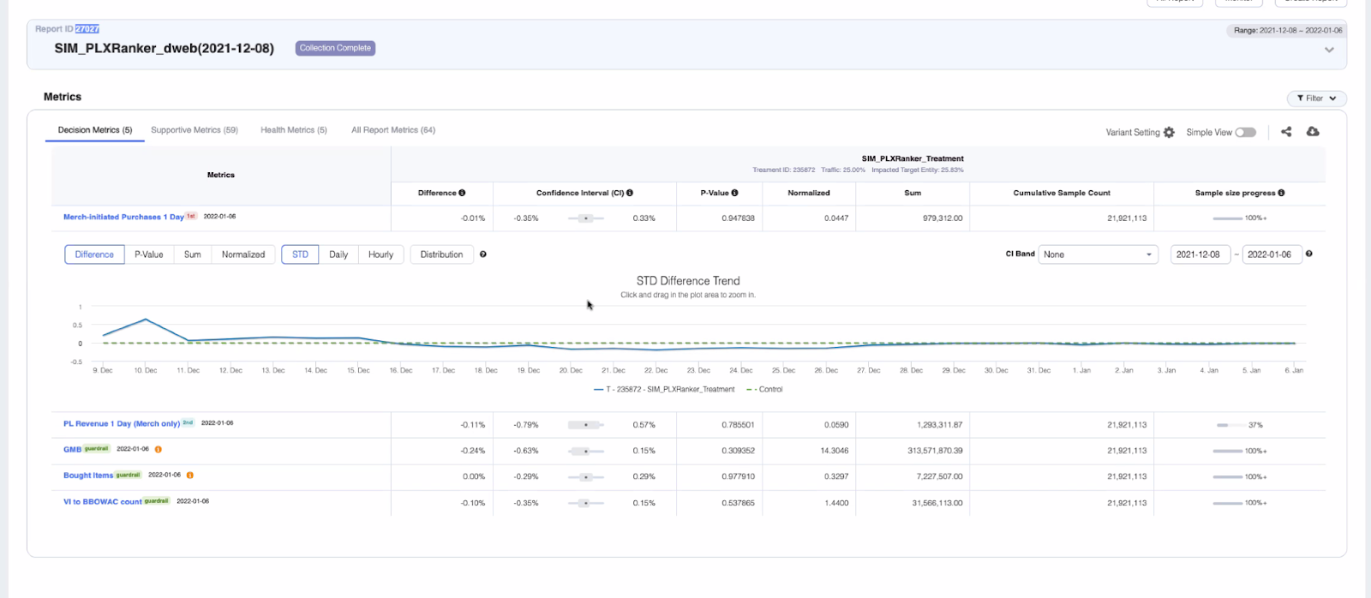

**Clark**

Algo pattern list updated - good enough list. Will start to check with PD.

need advice on how to reach out and communicate with them like what slack channel and who to email.

# Meeting 2/11

**Updates:**

**Hancheng:**

Add placement id in core metrics link to metadata changes with queryparams

**Clark:**

EP Time Series

Status

* Data in dev ES
* Working on update (or delete-then-write)

Index: ep_time_series_2022

An experiment has a list of histories

“histories”:

* "history": "116150",
* "duration": "38630",
* "actionType": "Update_Experiment",
* “Config”:
  + “servedTrafficPercentage”: “60”
  + “createTime”: 1641597540000
  + “updateTime”: 1641597591000
  + "timestamp":
    - "year": 2022,
    - "month": "JANUARY",
    - "nano": 0,
    - "monthValue": 1,
    - "dayOfMonth": 7,
    - "hour": 16,
    - "minute": 19,
    - "second": 59,
    - "dayOfYear": 7,
    - "dayOfWeek": "FRIDAY",
    - "chronology":
      * "id": "ISO",
      * "calendarType": "iso8601"

# Meeting 2/4

We may not need placement id filter from change event for those placements without traffic

Link from Core Metrics -> Metadata Changes

URL query params on Metadata Changes

Button to apply PL related/impact related

**Updates**

Clark

​​search logic here returns all the experiments whose start date and end date have intersection with the date range selected(experiment’s date range ‘2017-07-05 ~ 2022-12-12’ has intersection with 2022-01-26 ~ 2022-02-02),

Action: Currently doing EP time series

Xiaoyue

<https://ebay-eng.slack.com/archives/CPH9BKS0G/p1642707379244100>

2/3

Hi Xiaoyue, no problem.

I think this API goes along with the Touchtone report shown on UI, meaning that if the report is refreshed on the UI, the corresponding API will be updated. For completed experiment, I don’t think neither the API or the report will update.

Touchstone processed the data daily and there usually 2-3 days delay, so the API data shall be ready when you see numbers on the corresponding report.

Please check whether default.TS_SUMMARY_RESULTS is the HIVE table you need.

Action: Check with Srinivas for HIVE table query

# Meeting 1/28

Minutes 1/28/2022

[Clark]

Need to find a touchstone dev to help us with questions.

Question for touchstone team: tsexperiments API with start and end date retrieves all EP and UI just filters it.

check with #experimentation-support

[Xiaoyue]

Definition of Status “Active” is now different. might need to investigate more.

[Hancheng]

fixed time range bug and made the EP id filter call only when EP id length is 6.

blocked due to time series data not available from Clark

[Honghao]

Check if we might need a dedicated server for processing. Will sync up with Pavel.

# Meeting 1/21

**Action item**

Xiaoyue

* <https://touchstone-api.vip.ebay.com:8080/api/v1/result/cumulativelist/95346/12844?treatments=225073%2C225074&metrics=-1%2C113>
  + Check if report/trend have API that have parameters instead of us scraping and building our own

Clark

* EP time series data in ES

**Minutes from Meeting 1/21**

Dawei

* Future feature - percentage of traffic of EP in relation to all traffic
  + May or may not relate to revenue
* Backfill of data

Hancheng updates

* Time series
  + Active EPs

Xiaoyue updates

* Grab primary, secondary, and guardrail
* /cumulative
* Hourly dump - maybe check api



Clark updates

* Algo pattern
  + <https://docs.google.com/spreadsheets/d/1L5zOjK4ZJYBAZb3me51ujIpBAL5vgixsw6RXAcLUxvw/edit#gid=114602867>
* Green light on CR per EP ramp up/down
* Opt In?
  + ​​<https://touchstone-api.vip.ebay.com:8080/api/v1/sitedomains>?
  + <https://touchstone-api.vip.ebay.com:8080/api/v1/tsexperiments/100358>?
* JIRA
  + ​​<https://touchstone-api.vip.ebay.com:8080/api/v1/jira/get/issue/MADCCOE-1026>?
  + <https://touchstone-api.vip.ebay.com:8080/api/v1/monitor/releasenotes>?
* Time series
  + Audit logs <https://touchstone-api.vip.ebay.com:8080/api/v1/exptactivehistory/100358>?
  + Then filter by with served traffic

[**https://apisd.ebay.com/svcs/services/mobile/mes/v2/treatments**](https://apisd.ebay.com/svcs/services/mobile/mes/v2/treatments)

* **No user id**

**Meeting 1/14**

Action items:

Liz:

* [done] Share endpoint for native treatments
  + Native treatment API endpoint <https://apisd.ebay.com/svcs/services/mobile/mes/v2/treatments>

Clark

* Get User Id for Opt In
* Periodically get the EP. EP id as key. Store in new index.

Xiaoyue

* Work with PM to check with metrics important
* Share two endpoints:
  + /analyticalreports
  + /result/trend

Hancheng

* Time series demo

Updates during the meeting:

From Liz

* Page Opt
* Site vs Native
* Native has different factors
* Instead of ALGO.OVERRIDE.requestcategory
* From native, can’t access anything else
* Manually testing EP, there is DoD validation tool now.
* Can’t test on zero traffic. It must be 1%.
* For dWeb, i.e. drop. Opt In. GUID gets reset.
* GUID - Globally Unique Identifier as Device Identifier
* Sample: ​​<https://touchstone.vip.ebay.com/experiment/view?experimentId=100358>

Native treatments endpoint vs Touchstone

- what EPs are opted in

- what particular EP. a user is in and device

Pavel

* CCOE would add changes table below Core Metrics
* In Core Metrics, Page Family comes from ES which comes from ClickHouse

Xiaoyue

* https://touchstone-api.vip.ebay.com:8080/api/v1/analyticalreports/100064
* i.e. 10 days of EP run, metrics num are generated in Day 1. You cannot use the numbers for decision. You have to wait until EP finishes
* We can use the numbers as guardrails
* If there is a spike, then there is something wrong with EP

Hancheng

* demo EP id and placement id filter

**1/7 Updates**

ES - new index for EP time series - ep events

can ep can be reopened? If yes, same ep id or not? No.

EP Setup field duration - done

Raw data - done

​​

Follow up on change in multiple ramp up with Paul. - email sent

Re: Request for operation policy doc for CRs filed on EPs

* There is no operational policy documented for this . As per my understanding if there is change in site traffic cause due to each operation (eg pause/start/update),then there should be a respective CR that should be filed per operation. This would enable better traceability for SEC. We can have a discussion with touchstone on this .
* Some time back we decided not to have change tickets generated automatically for changes done on the Experiment Platform. We discovered that were ~40k Experiment changes per day being generated, and the volume was so high that we decided it wasn’t worth it. Part of the problem is that if there are that many tickets being generated all the time it becomes really hard to find the one experiment you might have been looking for.
* But if there are certain experiment changes with a higher risk profile, it would probably be a good idea to notify the SEC before you execute them. And it might also help to document the

**12/22 Updates**

Clark

EP Setup field duration - not started.

Raw data - batch job done. UI in progress.

Follow up on change in multiple ramp up with Paul. - email sent

Xiaoyue

discuss with Dong Liu RE: MADCDL query

yea Dong introduced a new api from TS to onboard the metrics, we can prolly switch the query to the api , I can share more info in the next meeting

Hancheng

* time series ep - in progress
* share placement id APIs - most are shared on demo meeting
* there is another endpoint to show all the active prod plmts

https://reco.ebay.com/service/v0/plmt?cfg=all

**Action items 12/18-12/24:**

- rerun and update EP info for all active EPs

- EP title

- audit log in folded

- filter function in Changes

Clark

* EP Setup field duration - not started.
* Raw data - batch job done. UI in progress.
* Follow up on change in multiple ramp up with Paul. - email sent

Xiaoyue

* discuss with Dong Liu RE: MADCDL query

Hancheng

* Time series EP
* share placement id APIs

**Discussion**

​​Active status definition has changed.

* Design phase is now active status as well
* How does this affect CR ticket?
* Xiaoyue to CC for this definition change

Placement level metrics?

Potential algo on placement ids

Dimension as algo

Q1 Core Metrics will have Algo in Clickhouse

* Clickhouse ownership CCOE to Euro team

How do we know if placement if EP? etc.

* Algo Domain?
* Migration of p id to p id

DQ placement id EP [shared in email]

[https://clickcubeapp.muse.vip.ebay.com/explore?start=1634529600&end=1635307200&chart=line&options={%22source%22:%22impressions%22,%22timezone%22:%22Etc/UTC%22,%22granularity%22:%22hour%22,%22dimensions%22:[%22placementId%22],%22measures%22:[%22count%22],%22filters%22:[{%22title%22:%22placementId%22,%22operator%22:%22in%22,%22values%22:[%22100276%22](https://clickcubeapp.muse.vip.ebay.com/explore?start=1634529600&end=1635307200&chart=line&options=%7B%22source%22:%22impressions%22,%22timezone%22:%22Etc/UTC%22,%22granularity%22:%22hour%22,%22dimensions%22:%5B%22placementId%22%5D,%22measures%22:%5B%22count%22%5D,%22filters%22:%5B%7B%22title%22:%22placementId%22,%22operator%22:%22in%22,%22values%22:%5B%22100276%22)]}]}

Find traffic over time for EP and graph

Add algo to click house

**Action items 12/10-12/17:**

- rerun and update EP info for all active EPs

- EP title

- audit log in folded

- filter function in Changes

Clark

* EP Setup field except algo pattern, duration

Xiaoyue

* discuss with Dong Liu RE: MADCDL query

Hancheng

* Time series EP

**Meeting 12/10**

**Placement ids**

Traffic per placement ids

Transfer of traffic from placement id to another

Multi-select on placement ids

Multi-search on placement ids

Metadata for placement ids

Merch BU is very broad

**Talk to EP for every PM to standardized**

Ads revenue related (placement ids) in touchstone

But placement id is not a common field

Let them structure the data but placement id is not mandatory for others

May take 1 year to complete this

**Action items:**

Clark

- EP Setup field except algo pattern

- EP Validation - scan and retrieve info from JIRA (<https://wiki.vip.corp.ebay.com/display/jiraproduct/OAuth+for+Jira+APIs>)

- core metrics are annotation UI

Action items:

- rerun and update EP info for all active EPs

- EP title

- audit log in folded

- filter function in Changes not Group By (which is a big feature)

Xiaoyue

- EP Evaluation: shepherd backend - add query on MADCDL (ep id and dates on touchstone tables)

- purpose: before EP ends - get a prediction whether positive or negative. why? Before, the EP conclusion was taking a long time.

- new action item: discuss with Dong Liu

- automate query?

- query for metrics on each EP

- query only meaningful after 10 days but PM ends EP before 10 days (any prediction before the power is not useful - we thought before that we only need 2-3 days for prediction and not 10 days)

- with a certain amount of traffic, how much power needed for EP

- what is the level of power that makes it statistically significant

Question:

- do we still proceed with the query?

- if yes, how to link the response

Hancheng

- time series table data structure for an EP

- Status

- last_update_user

- ep changes table

- real-time token for change log

- variants

Experiment status (any change has CR)

**Request to EP team**

**Meeting with Weiyu Zhou**

EP exit

Filter by EP

I have EP - let’s say 5 to six placements. Can we see if its a specific placement?

Scope for EP scrubbing

Any good way to identify if BU is the one affecting?

Add EP to monitor it

EP flagging.

Add our own EP - maybe provide a template to know which placement impacts

**Action item:** Add all BU in EP and just filter by business unit

Do a query for EP with traffic

Page related EPs, pricing

Estimate: 5000 EPs per year

**Raw minutes of the meeting 12/1**

How many parallel projects going on

Define the project and sub-projects

Ownership

Timeline

* EP Setup fields
* EP Dashboard
* EP Scheduling and Calendar
* EP Validation
* Realtime traffic monitoring
* Onboarding MADCDL Query
* End of 2022 Q2 - EP Dashboard with more info, realtime data, graph, EP lifecycle
* 2021 Q4
  + DONE
    - get the query ready and runnable
  + EP Setup field except algo pattern - Clark
  + EP Validation - scan and retrieve info from JIRA - Clark - talk to Huiwen (huyu) on how to pull from JIRA i.e. 7 days or 1 week.
    - JIRA ticket status
    - QE assignee
    - timeline of test
  + EP Evaluation: shepherd backend - add query on MADCDL (ep id and dates on touchstone tables) - xiaoyue (until 2022 Q1)  
    - shepherd UI 2022 Q1
  + time series table for an 1 EP - hancheng
    - data needed: EP name, traffic, status
    - priority data structure - hancheng
* 2022 Q1
  + EP Setup field - algo pattern
  + EP Run
  + EP Evaluation: shepherd UI 2022 Q1
* 2022 Q2
  + EP Run UI
  + EP Conclusion - after evaluation. ramp down.if number is looking good, continue to run EP. then if still good, launch algo.
    - if numbers looking bad, change status to PAUSE/STOP.
    - each EP has different intentions - diff from each PMs - xiaoyue
      * i.e. gathering data for certain variant - this use case will not be launched

problem - current batch job is dependent on servicenow ticket for EP.

Don't query: (smoke testing, pause, complete), - does not affect traffic really because 1%.

start (multiple) - affect traffic more

update - depends on the factor value

batch job for active EPs - to check their history of status + servedtraffic

data design

* structure
* type
* values

Dependencies per phase

tasks that can be done in parallel

Project description

EP Enhancement project aims to provide more visibility/observability when the root cause of a decrease in a business metric is related to experimental learning receiving traffic.

**Meeting 11/24**

Clark

* Batch job to include EP setup fields - in progress. Might need to create a separate EP index in ES
  + [Batch Job scraping changes and EP metadata](https://github.corp.ebay.com/adssre/adssrejob)
  + [ES prod for change metadata](https://esadsquality-kibanaslc.vip.ebay.com/app/kibana#/discover?_g=(refreshInterval:(pause:!t,value:0),time:(from:now-7d,to:now))&_a=(columns:!(_source),index:'23f94d00-214a-11ec-9a71-19eb6bfa8bcd',interval:auto,query:(language:kuery,query:''),sort:!(!(createAt,desc))))
* Check with Ganesh for data structure with seller side - no action needed
* UI design

Xiaoyue - PTO

* Reach out to Loraine/catherine? Regarding how to automate EP query. - in progress
* Work with Dong with minimum data size or query. - in progress

Hancheng

* EP Dashboard UI
* PromQL findings explanation
  + Use cases UI
  + Dynamic panel
* UI design - FYI Performance tab will be merged with Business tab in Core Metrics.

**Meeting 11/18**

Clark

* Batch job to include EP setup fields
* Check with Ganesh for data structure with seller side
* UI design

Xiaoyue

* Reach out to Loraine/catherine? Regarding how to automate EP query. - in progress
* Work with Dong with minimum data size or query. - in progress

Hancheng

* EP Dashboard UI - learning React/JavaScript
* PromQL findings explanation
  + Use cases UI
  + Dynamic panel
* UI design - FYI Performance tab will be merged with Business tab in Core Metrics.

Meeting notes

From Xiaoyue:

* Validator - ​​ticket closer - which QE tested/closed this ticket
* Start time - end time affects ramp up. start time might not be useful?
* Results - contents of the JIRA ticket. status, etc. check JIRA API

Group discussion:

* Show EP individually
* Core Metrics to link to a different page to show EP dashboard i.e. ramp up / ramp down
* Button for change related i.e. below the Core Metrics graph.
* List of core_roll/experiments
* 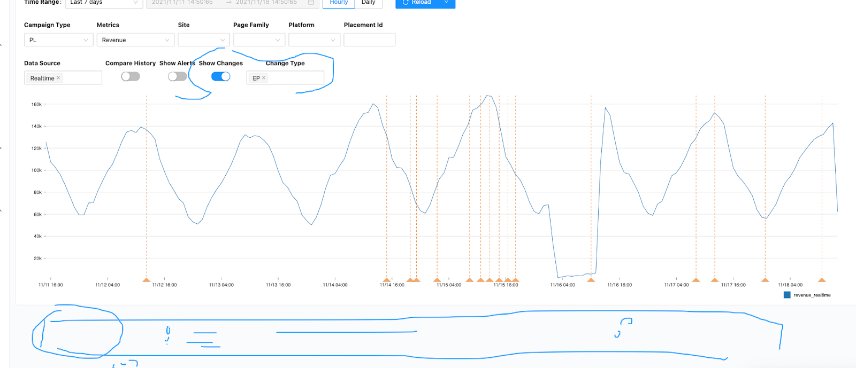
* XX Event: ramp up, etc.
* Placement id? Traffic graph comparison with revenue??? (Another dimension) Another UI
* As a user, I should see a vertical line in the same timestamp in EP dashboard when I hover over a point in a graph (timestamp) in the Core Metrics dashboard and vice versa.
* What impacts the revenue? Traffic? With same time range

Core Metrics > PL Revenue

X - time

Y - revenue

EP traffic

X - time

Y - traffic percentage

Example in grafana when you hover in a graph, the two vertical red lines are synchronized:

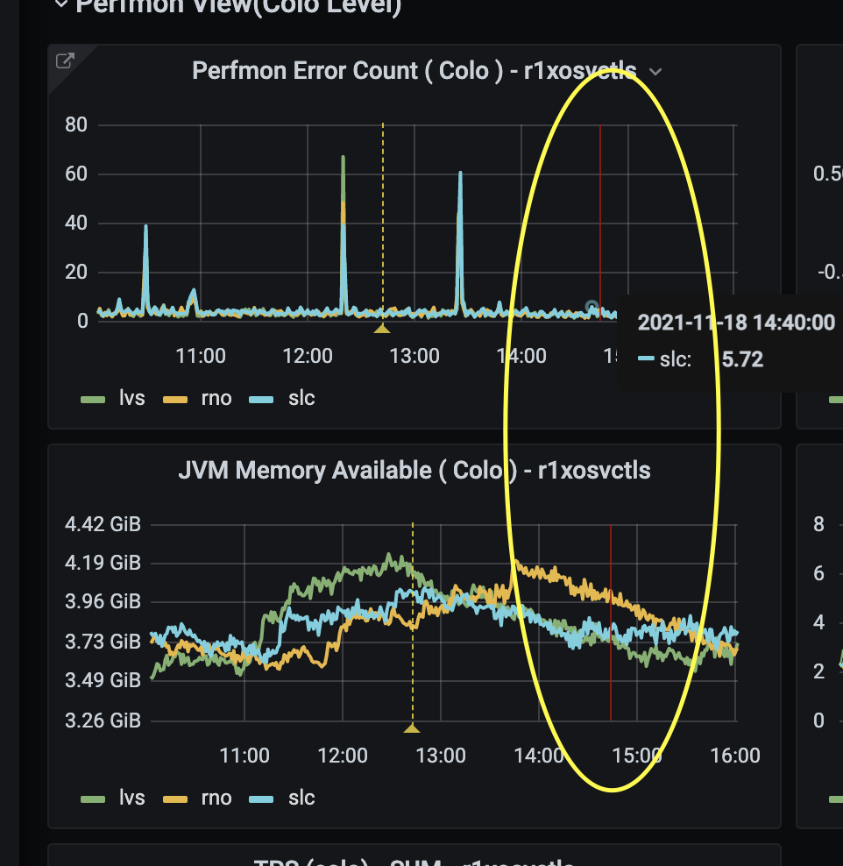

Previous Action items:

Clark

* metricOutcomes - reach out to touchstone team if they don’t change or not.
  + The metricOutcomes stands for the metrics expectation of the EP before any start, hence its change frequency depends on EP's owner
  + the metric ids and names mapping does not change
* ticket/feature: JIRA ticket link
  + Created
* Algo pattern scrape - talk to PD, we can check the category. - different parser for different teams. Maybe map algo and placement ids. If we fail to parse placement id, ask PM to put that. Sanity check to ep parsers.
  + EP project: from EP Team: list of creators - adanesh jbligh jingshao mgearhart mkhan7 pramore whairan wilau xiaoyuezhang - need to figure out which team they are from
* EP setup every field is covered in the API
* Meet in honghao in Monday structured info
  + Core metrics/concepts should not be nested.
  + Who are users of ES and Control Center

Xiaoyue

* Scope EP Validation - in google sheets
* AllRelatedExpts - not useful. https://ebay-eng.slack.com/archives/CPH9BKS0G/p1637266477024800
* Reach out to Loraine/catherine? Regarding how to automate EP query. - in progress
* Work with Dong with minimum data size or query. - in progress
* got confirmation from Vishal from ranking team , the info they use in debugging should be within factor value as well, so I think for majority of the merch tests factor value should contain sufficient data points for investigation

Hancheng

* Backend service config and env with Clark. - done.
* Talk to Zhangyu about PromQL rule
* sum( rr: mfe_experiment_id{_namespace_="reco"}) by (experiment_id)
* [promQL EP](https://console.sherlock.io/explore?orgId=1&left=%5B%22now-7d%22,%22now%22,%22Sherlock-PromQL%22,%7B%22exemplar%22:true,%22expr%22:%22sum(rr:mfe_experiment_id%7B_namespace_%3D%5C%22reco%5C%22%7D)%20by%20(experiment_id)%22,%22requestId%22:%22Q-93a5a3a1-6155-43c9-bd5c-a7408c3a6d7c-0A%22,%22hide%22:false%7D%5D)

**Meeting Summary**

**11/12**

Agenda

* Recap our findings
* Start adding new ep fields in ES
  + Info.channel, info.plane, info.traffic, etc.
* Add raw data column in Control Center for EP
* Start data collection research/discussion on EP Validation
* New action items

Action item:

**Clark**

* metricOutcomes - reach out to touchstone team if they don’t change or not.
  + The metricOutcomes stands for the metrics expectation of the EP before any start, hence its change frequency depends on EP's owner
  + the metric ids and names mapping does not change
* ticket/feature: JIRA ticket link
  + Created
* Algo pattern scrape - talk to PD, we can check the category. - different parser for different teams. Maybe map algo and placement ids. If we fail to parse placement id, ask PM to put that. Sanity check to ep parsers.
* EP setup every field is covered in the API
* Meet in honghao in Monday structured info

Xiaoyue

* Scope EP Validation
* AllRelatedExpts
* Reach out to Loraine/catherine? Regarding how to automate EP query.
* Work with Dong with minimum data size or query.

Hancheng

* Backend service config and env with Clark.
* Talk to Zhangyu about PromQL rule
  + sum( rr: mfe_experiment_id{_namespace_="reco"}) by (experiment_id)
  + [promQL EP](https://console.sherlock.io/explore?orgId=1&left=%5B%22now-7d%22,%22now%22,%22Sherlock-PromQL%22,%7B%22exemplar%22:true,%22expr%22:%22sum(rr:mfe_experiment_id%7B_namespace_%3D%5C%22reco%5C%22%7D)%20by%20(experiment_id)%22,%22requestId%22:%22Q-93a5a3a1-6155-43c9-bd5c-a7408c3a6d7c-0A%22,%22hide%22:false%7D%5D)

Findings

* metricOutcomes in <https://touchstone-api.vip.ebay.com:8080/api/v1/tsexperiments/98877>
  + metricIds of primaryMetric, secondaryMetrics, and guardRailMetrics
  + Example: guardrails: 113 - gmb, 111 - bought_items, 897 - BBOWAC_count
  + <https://touchstone-api.vip.ebay.com:8080/api/v1/metricdefs/113>
  + <https://touchstone.vip.ebay.com/experiment?id=99764&reportId=26505>

Milestone

* v1 : EP Setup data in Control Center/ES

**11/7:**

Findings:

* Algo
  + factor.name depends not algo all the time. different teams have different syntax.
    - <https://touchstone-api.vip.ebay.com:8080/api/v1/tsexperiments/99642>
    - ALGO.override: <https://touchstone-api.vip.ebay.com:8080/api/v1/tsexperiments/99764>
  + solution: store data. for 1 month. get all name for all patterns. pattern to each team. run historical data. maybe in august data. then we can do some analysis. parameterized batch job. <https://jirap.corp.ebay.com/browse/SHEPHERD-512>
  + require: we need all different factor types examples.
* Channel are different platforms - we can have a fixed lookup for the names given ids
* EP Run (need multiple CRs to detect impact) - not blocker. confirm with the EP team which one is EP state in JSON response. <https://ebay-eng.slack.com/archives/CPH9BKS0G/p1635890482223200>

Action items:

* Xiaoyue - confirm data requirements and search EP by control. id? algo? ask from other QE members.
  + ​​hey [@cjasonbautista](https://ebay-eng.slack.com/team/U02AJT5UGQ4) I took a look at the api again and found something might be useful ,1. so in the response there is a approvalDoc field , this leads to the DOD jira ticket , I think we can pull dod info directly from this field , eg when the ticket is updated , duration ,owner , if its closed etc
  + 2. I found this field allRelatedExpts , it has a list of other EPs , not sure how they are related ? I checked some of them , they don’t share same owners or planes tho
  + also based on our last convo, I gathered two DOD tickets from my team for different types of tests , one is from VI team and one is from algo team ,
  + you can see we check different things for different tests
  + algo:<https://touchstone.vip.ebay.com/experiment/view?experimentId=99827> -<https://jirap.corp.ebay.com/browse/ALACARTE-336>
  + VI :<https://touchstone.vip.ebay.com/experiment/view?experimentId=99642> -<https://jirap.corp.ebay.com/browse/MADSNAP-4357>
  + looks like different teams have different way to fill the validation results in their DOD tickets
  + and some even upload doc files, if we want to grab info from here, we have to align all the teams have the same contract to fill input validation steps & results
* Clark - sync up structure info with Honghao
  + capture raw data.
  + Need to sync up again for ES structure
* Hancheng - check with MFE
  + ​​hi [@cjasonbautista](https://ebay-eng.slack.com/team/U02AJT5UGQ4) actually we don't have MFE fully owned eps, however a lot eps are MFE-related e.g. algotargeting, po, plmt and so on
  + I have checked some DOD tickets from different teams
  + PageOpt:<https://touchstone.vip.ebay.com/experiment/view?experimentId=99383> -<https://jirap.corp.ebay.com/browse/PLBUYER-4820>
  + ads native:<https://touchstone.vip.ebay.com/experiment/view?experimentId=99634> -<https://jirap.corp.ebay.com/browse/MOBILADS-5031>
  + MAD CCOE:<https://touchstone.vip.ebay.com/experiment/view?experimentId=99417> -<https://jirap.corp.ebay.com/browse/MOBILADS-4960>
  + <https://touchstone.vip.ebay.com/experiment/view?experimentId=99256> -<https://jirap.corp.ebay.com/browse/MADCCOE-694>

**10/29**: Pavel organized a meeting on implementation of the P1 tasks

**10/20**: Ganesh and Dawei met to discuss Seller side EP use cases - [Identified Action Items and Priority](https://docs.google.com/document/d/170IJO6VHVQFNRO9gSAeqlQNojnj6tMktT63tsnl_35k/edit#bookmark=id.9fw5ojg0dxch)

**10/13**: Xiaoyue, Paval and Dawei met again to finalize the data list and identify the current P1 items to work on.

**10/7**: Xiaoyue, Paval and Dawei met to go over the following.

Next: more teams will be involved to finalize the implementation plan.

Here listed the phases that we would like to track within ControlCenter, for visibility and triage (event correlation) purposes. Within each phase, let’s work on defining 1) the concise set of info to collect and; 2) critical events to log and show; 3) how to connect all related info/events on the dashboard.

UI Wireframe

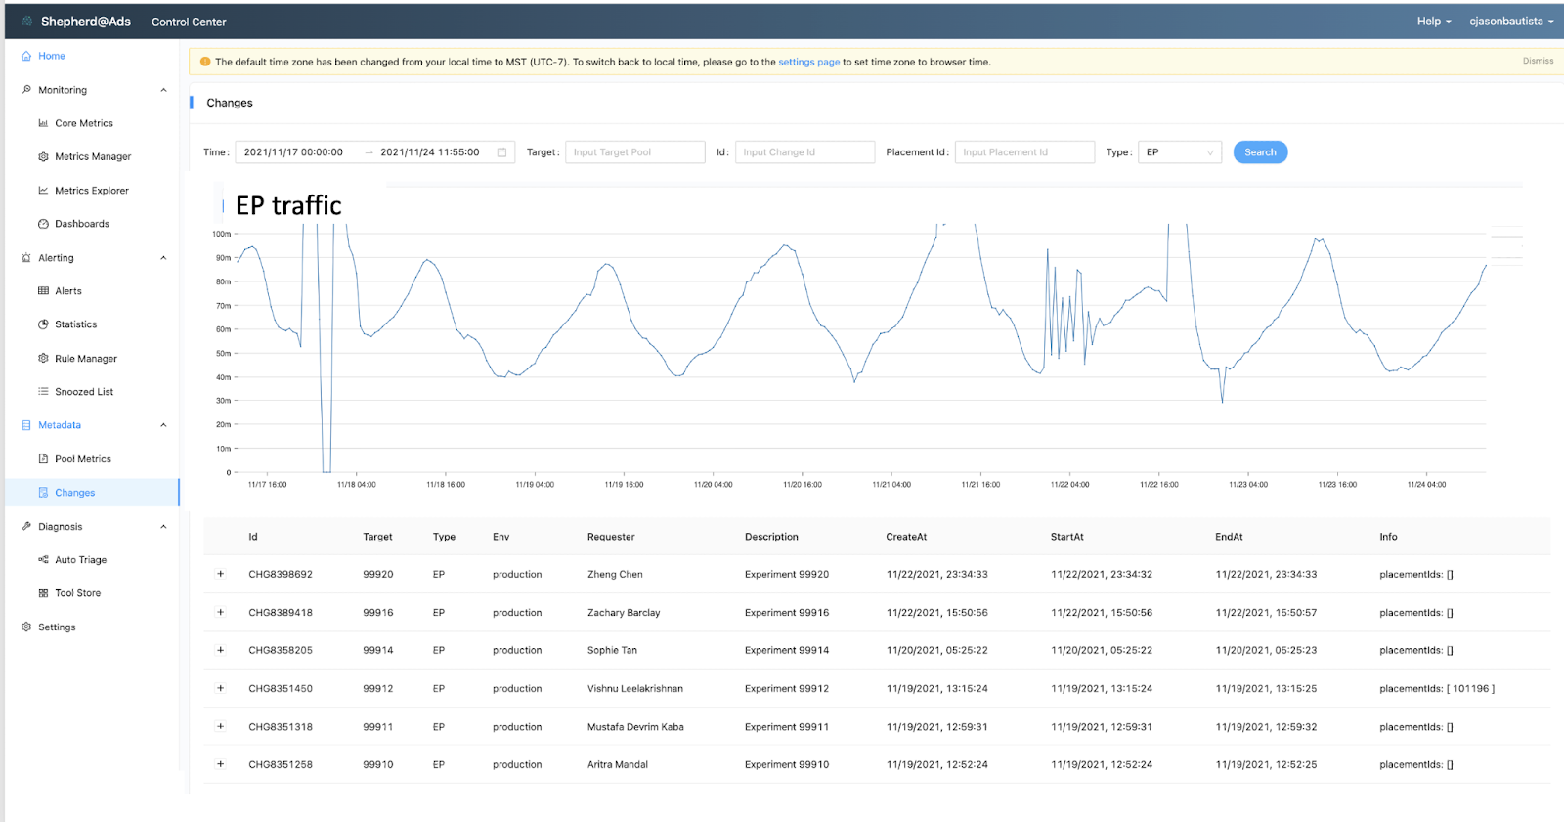

**EP Outline**

1. EP candidate table and scheduling(working with Josh/PMs)
   1. Structured info (Honghao)
   2. Current PM maintained EP list ( [here](https://nam01.safelinks.protection.outlook.com/?url=https%3A%2F%2Fdocs.google.com%2Fspreadsheets%2Fd%2F1szdOziD21peQOcLckLskmbloMGFWbWnSh8BWMMukz6o%2Fedit%3Fusp%3Dsharing&data=04%7C01%7Cdawwang%40ebay.com%7Ca8c777ca9af3490dad5508d8a761f6c7%7C46326bff992841a0baca17c16c94ea99%7C0%7C0%7C637443386498865540%7CUnknown%7CTWFpbGZsb3d8eyJWIjoiMC4wLjAwMDAiLCJQIjoiV2luMzIiLCJBTiI6Ik1haWwiLCJXVCI6Mn0%3D%7C1000&sdata=dqTrohlfvg71UogV%2BFooyVYVE3GFLn8aDkzil7p956I%3D&reserved=0), go/merchab)
2. EP Setup (**PM & domain QEs**)
   1. Info
      1. Ownership
      2. Factor related
      3. Placements
      4. Planned plane, traffic and duration
         1. Planned plane - ​​allocation of traffic it can consists of multiple EPs. EPs running on the same plane (parallel) to save traffic. They are not affecting one another. capture this.
      5. Leverage the new feature flag API
      6. Projected Treatment vs control
         1. 1 control for multiple treatments
      7. Related Algos for correlation? (Ganesh); Clickhouse data (Tim)
   2. Event:
      1. Scan for conflicts
3. EP validation automation status (Domain **QEs**):
   1. Info
      1. Validator
      2. Time
      3. Results
      4. EP id
   2. Events: NA
4. EP run cycle (PM & domain QEs)
   1. Runtime Info:
      1. Traffic plane
      2. Treatments vs Control
      3. %
      4. Other metadata (please define)
   2. Events:
      1. Ramp-up
      2. change/pause
      3. ramp-down
   3. EP ramp up
      1. Info:
         1. Target %
      2. events:
         1. Realtime dashboard - each EP id
         2. Event or alert or notation
            1. Traffic disparity?
            2. Data issue - Ganesh
            3. What else could be the anomaly ?
   4. EP Changes/Pause
      1. Info
   5. EP ramp down
      1. Info:
         1. Target %
      2. events:
         1. Realtime dashboard - each EP id
         2. Event or alert or notation
            1. Traffic disparity
            2. What else could be the anomaly ?
5. EP evaluation (QE)
   1. Info
      1. Leveraging Analytics’ MADCDL query (major biz metrics and their binary versions) to onboard ControlCenter (self service)
   2. Event:
      1. Metrics and Alerting rules
6. EP conclusion (what signal/info/flag)
   1. Whether meeting the hypothesis specified
   2. Email to PM to confirm and note down conclusion
7. Other Page/client EPs (VI, ...) (Page QEs + merch QEs)

* Most merch concerning EPs on pages where Merch presents

**Potential Tasks**:

* Identifying a key to connect everything together - EP id()
  + Structure meta
  + Change push API
* **Ways to detect conflicts during setup phase- How?** (Potential)
  + phase1 : Checklist (Xiaoyue&Praj)
  + Phase2: Abstract the business practice to identify potential conflict
* Feature Flag API - how to leverage it for our case**?**
* **MADCDL query - Xiaoyue**
* Seller side EP use cases - Ganesh (CR) - Dawei
* **Creating sheet for data collection** - (P0)
  + Source (where to collect the data, potentially most from CRs, confirm with EP PMs)
  + Availability
  + Priority
* **EP Automation test info**
* Page side EPs
* Priority
* All change requires a CR
  + EP CR should cover:
* EP Candidate table and scheduling

### Identified Action Items and Priority

| Item | Priority |  | Owner | Timeline | Status |
| --- | --- | --- | --- | --- | --- |
| Data in CR | P1 | Confirm most data can be retrieved from CR | Pavel/Xiaoyue |  | WIP |
| Defining Data Set | P1 | Based on the phases, identifying the | Dawei, Ganesh, Pavel, Xiaoyue |  | Link to [Sheet](https://docs.google.com/spreadsheets/d/1L5zOjK4ZJYBAZb3me51ujIpBAL5vgixsw6RXAcLUxvw/edit#gid=0) |
| EP Validation | P1 | Based on EP DoD JIRA to get the EP validation related info | Xiaoyue |  |  |
| Onboarding MADCDL query | P1 | To evaluate EP performance with a relatively small set of samples. | **Xiaoyue** |  | WIP |
| realtime EP traffic monitor | P1 | Onboarding to ControlCenter | ControlCenter Team |  |  |
| EP Dashboard | P1 | ControlCenter team design the flow representation and implement the dashboard | **Clark/Pavel**,  Hancheng to support this effort |  |  |
| Seller Side Data source and structure | P2 | Ganesh to add the spec | **Ganesh** |  |  |
| EP Scheduling &Calendar | P3 |  |  |  |  |

Notes:

EP related info can be retrieved from TS api eg <https://touchstone-api.vip.ebay.com:8080/api/v1/tsexperiments/99158>

PROPOSED DATA in ES

DATA in ES

{

"id":"CHG8147386",

"createAt":"2021-11-02T16:53:26.000Z",

"startAt":"2021-11-02T16:53:26.000Z",

"endAt":"2021-11-02T16:53:27.000Z",

"type":"EP",

"env":"production",

"requester":"Josh Bligh",

"target":"99749",

"description":"Experiment 99749",

"data":"[]",

"experimentName":"Lex1multiseed_Replacement_MyeBay_DWeb",

"approvalDoc":"https://jirap.corp.ebay.com/browse/MADSNAP-4423",

"businessUnit":"21",

"owner":"jbligh",

"effectStart":null,

"effectEnd":null,

"options":{

}

}

**User Stories**

​​

As a user,

... I can view EP Dashboard

... I can view EP Candidate Table

... I can view EP Setup

... I can view placement ids

... I can view EP Validation automation status

... I can view EP run cycle

... I can view EP ramp up

... I can view EP Changes/Pause

... I can view EP ramp down

... I can view EP evaluation

... I can view EP conclusion

... I can view Other Page

**PromQL explanation**

1. Rules Group set up for reco app

<https://cloud.ebay.com/rule-groups> → ATMos

The newly created rule to record ep count changes in atmos_ep_count

sum(increase(ep_treatment_total{_namespace_="reco", namespace="reco"}[1m])) by (experiment_id, treatment_id, request_group)

This rule recorded the increase count by experiment id + treatment id + request group(plmt ids) per minute.

Reference promQL cheatsheet

<https://promlabs.com/promql-cheat-sheet/>

1. PromQL query through sherlock-io

Example query to sum up the ep count by experiment id

sum(rr:mfe_ep_count{_namespace_="reco"}) by (experiment_id)

<https://console.sherlock.io/explore?orgId=1&left=%5B%22now-7d%22,%22now%22,%22Sherlock-PromQL%22,%7B%22exemplar%22:true,%22expr%22:%22sum(rr:mfe_ep_count%7B_namespace_%3D%5C%22reco%5C%22%7D)%20by%20(experiment_id)%22,%22requestId%22:%22Q-93a5a3a1-6155-43c9-bd5c-a7408c3a6d7c-0A%22,%22hide%22:false%7D%5D>

Example query to sum up the ep count by any call matching specific placement 101110

rr:mfe_ep_count{_namespace_="reco", request_group=~".*101110*."}

[https://console.sherlock.io/explore?orgId=1&left=%5B%22now-7d%22,%22now%22,%22Sherlock-PromQL%22,%7B%22exemplar%22:true,%22expr%22:%22rr:mfe_ep_count%7B_namespace_%3D%5C%22reco%5C%22,%20request_group%3D~%5C%22.*101110*.%5C%22%7D)%22,%22requestId%22:%22Q-93a5a3a1-6155-43c9-bd5c-a7408c3a6d7c-0A%22,%22hide%22:false%7D%5D](https://console.sherlock.io/explore?orgId=1&left=%5B%22now-7d%22,%22now%22,%22Sherlock-PromQL%22,%7B%22exemplar%22:true,%22expr%22:%22rr:mfe_ep_count%7B_namespace_%3D%5C%22reco%5C%22,%20request_group%3D~%5C%22.*101110*.%5C%22%7D)%22,%22requestId%22:%22Q-93a5a3a1-6155-43c9-bd5c-a7408c3a6d7c-0A%22,%22hide%22:false%7D%5D)

# Outlook Zoom meeting message history dump

Hi All,

See you on Thursday for EP change metadata enhancement

[Ads EP Dashboard on ControlCenter (WIP)](https://nam10.safelinks.protection.outlook.com/?url=https%3A%2F%2Fdocs.google.com%2Fdocument%2Fd%2F170IJO6VHVQFNRO9gSAeqlQNojnj6tMktT63tsnl_35k%2Fedit&data=04%7C01%7Ccjasonbautista%40ebay.com%7C0f9479d0221447f2e65e08d9fe23a866%7C46326bff992841a0baca17c16c94ea99%7C0%7C0%7C637820251381987971%7CUnknown%7CTWFpbGZsb3d8eyJWIjoiMC4wLjAwMDAiLCJQIjoiV2luMzIiLCJBTiI6Ik1haWwiLCJXVCI6Mn0%3D%7C3000&sdata=Lt1ItKxJ6xsCyl9s%2F6mrKCJ8iRl1cYYD50lHjeOULvY%3D&reserved=0)

[Data Collection for EP Flow Dashboard](https://nam10.safelinks.protection.outlook.com/?url=https%3A%2F%2Fdocs.google.com%2Fspreadsheets%2Fd%2F1L5zOjK4ZJYBAZb3me51ujIpBAL5vgixsw6RXAcLUxvw%2Fedit%23gid%3D0&data=04%7C01%7Ccjasonbautista%40ebay.com%7C0f9479d0221447f2e65e08d9fe23a866%7C46326bff992841a0baca17c16c94ea99%7C0%7C0%7C637820251381987971%7CUnknown%7CTWFpbGZsb3d8eyJWIjoiMC4wLjAwMDAiLCJQIjoiV2luMzIiLCJBTiI6Ik1haWwiLCJXVCI6Mn0%3D%7C3000&sdata=aTr%2BJ8BsGeea8AA%2BDK1IAUDRAhjGBfhuQ3FoKgM2muQ%3D&reserved=0)

Clark

**From:** Jason Bautista, Clark(AWF) <cjasonbautista@ebay.com>

**Date:** Friday, March 25, 2022 at 9:50 AM

**To:** Liu, Pavel <yualiu@ebay.com>, Zhang, Xiaoyue <xiaoyuezhang@ebay.com>, Xiao, Hancheng <hanxiao@ebay.com>, Wang, Honghao <hongwang@ebay.com>, Wang, Dawei <dawwang@ebay.com>

**Cc:** Huang, Yichao <yichhuang@ebay.com>, Wang, Freecia <freewang@ebay.com>, More, Prajakta <pramore@ebay.com>, Iyamperumal, Ganesh <gaiyamperumal@ebay.com>, Hernandez, Elizabeth <eahernandez@ebay.com>

**Subject:** EP metadata change enhancement weekly sync up

Hi All,

See you on Thursday for EP change metadata enhancement

[Ads EP Dashboard on ControlCenter (WIP)](https://nam10.safelinks.protection.outlook.com/?url=https%3A%2F%2Fdocs.google.com%2Fdocument%2Fd%2F170IJO6VHVQFNRO9gSAeqlQNojnj6tMktT63tsnl_35k%2Fedit&data=04%7C01%7Ccjasonbautista%40ebay.com%7C0f9479d0221447f2e65e08d9fe23a866%7C46326bff992841a0baca17c16c94ea99%7C0%7C0%7C637820251381987971%7CUnknown%7CTWFpbGZsb3d8eyJWIjoiMC4wLjAwMDAiLCJQIjoiV2luMzIiLCJBTiI6Ik1haWwiLCJXVCI6Mn0%3D%7C3000&sdata=Lt1ItKxJ6xsCyl9s%2F6mrKCJ8iRl1cYYD50lHjeOULvY%3D&reserved=0)

[Data Collection for EP Flow Dashboard](https://nam10.safelinks.protection.outlook.com/?url=https%3A%2F%2Fdocs.google.com%2Fspreadsheets%2Fd%2F1L5zOjK4ZJYBAZb3me51ujIpBAL5vgixsw6RXAcLUxvw%2Fedit%23gid%3D0&data=04%7C01%7Ccjasonbautista%40ebay.com%7C0f9479d0221447f2e65e08d9fe23a866%7C46326bff992841a0baca17c16c94ea99%7C0%7C0%7C637820251381987971%7CUnknown%7CTWFpbGZsb3d8eyJWIjoiMC4wLjAwMDAiLCJQIjoiV2luMzIiLCJBTiI6Ik1haWwiLCJXVCI6Mn0%3D%7C3000&sdata=aTr%2BJ8BsGeea8AA%2BDK1IAUDRAhjGBfhuQ3FoKgM2muQ%3D&reserved=0)

Clark

**From:** Jason Bautista, Clark(AWF) <cjasonbautista@ebay.com>

**Date:** Monday, March 21, 2022 at 10:45 PM

**To:** Liu, Pavel <yualiu@ebay.com>, Xiao, Hancheng <hanxiao@ebay.com>, Wang, Dawei <dawwang@ebay.com>, Wang, Honghao <hongwang@ebay.com>, Zhang, Xiaoyue <xiaoyuezhang@ebay.com>

**Cc:** More, Prajakta <pramore@ebay.com>, Iyamperumal, Ganesh <gaiyamperumal@ebay.com>, Wang, Freecia <freewang@ebay.com>, Hernandez, Elizabeth <eahernandez@ebay.com>, Huang, Yichao <yichhuang@ebay.com>

**Subject:** EP metadata change enhancement weekly sync up

Hi All,

See you on Thursday for EP change metadata enhancement. Let’s meet earlier due to some availability conflicts.

[Ads EP Dashboard on ControlCenter (WIP)](https://nam10.safelinks.protection.outlook.com/?url=https%3A%2F%2Fdocs.google.com%2Fdocument%2Fd%2F170IJO6VHVQFNRO9gSAeqlQNojnj6tMktT63tsnl_35k%2Fedit&data=04%7C01%7Ccjasonbautista%40ebay.com%7C0f9479d0221447f2e65e08d9fe23a866%7C46326bff992841a0baca17c16c94ea99%7C0%7C0%7C637820251381987971%7CUnknown%7CTWFpbGZsb3d8eyJWIjoiMC4wLjAwMDAiLCJQIjoiV2luMzIiLCJBTiI6Ik1haWwiLCJXVCI6Mn0%3D%7C3000&sdata=Lt1ItKxJ6xsCyl9s%2F6mrKCJ8iRl1cYYD50lHjeOULvY%3D&reserved=0)

[Data Collection for EP Flow Dashboard](https://nam10.safelinks.protection.outlook.com/?url=https%3A%2F%2Fdocs.google.com%2Fspreadsheets%2Fd%2F1L5zOjK4ZJYBAZb3me51ujIpBAL5vgixsw6RXAcLUxvw%2Fedit%23gid%3D0&data=04%7C01%7Ccjasonbautista%40ebay.com%7C0f9479d0221447f2e65e08d9fe23a866%7C46326bff992841a0baca17c16c94ea99%7C0%7C0%7C637820251381987971%7CUnknown%7CTWFpbGZsb3d8eyJWIjoiMC4wLjAwMDAiLCJQIjoiV2luMzIiLCJBTiI6Ik1haWwiLCJXVCI6Mn0%3D%7C3000&sdata=aTr%2BJ8BsGeea8AA%2BDK1IAUDRAhjGBfhuQ3FoKgM2muQ%3D&reserved=0)

Clark

**From:** Jason Bautista, Clark(AWF) <cjasonbautista@ebay.com>

**Date:** Saturday, March 12, 2022 at 12:37 AM

**To:** Liu, Pavel <yualiu@ebay.com>, Wang, Dawei <dawwang@ebay.com>, Zhang, Xiaoyue <xiaoyuezhang@ebay.com>, Xiao, Hancheng <hanxiao@ebay.com>, Wang, Honghao <hongwang@ebay.com>

**Cc:** Huang, Yichao <yichhuang@ebay.com>, Hernandez, Elizabeth <eahernandez@ebay.com>, Iyamperumal, Ganesh <gaiyamperumal@ebay.com>, Wang, Freecia <freewang@ebay.com>, More, Prajakta <pramore@ebay.com>

**Subject:** EP metadata change enhancement weekly sync up

Hi All,

See you on Thursday for EP change metadata enhancement. Let’s reduce meeting time to 30 mins and see how it goes =)

[Ads EP Dashboard on ControlCenter (WIP)](https://nam10.safelinks.protection.outlook.com/?url=https%3A%2F%2Fdocs.google.com%2Fdocument%2Fd%2F170IJO6VHVQFNRO9gSAeqlQNojnj6tMktT63tsnl_35k%2Fedit&data=04%7C01%7Ccjasonbautista%40ebay.com%7C0f9479d0221447f2e65e08d9fe23a866%7C46326bff992841a0baca17c16c94ea99%7C0%7C0%7C637820251381987971%7CUnknown%7CTWFpbGZsb3d8eyJWIjoiMC4wLjAwMDAiLCJQIjoiV2luMzIiLCJBTiI6Ik1haWwiLCJXVCI6Mn0%3D%7C3000&sdata=Lt1ItKxJ6xsCyl9s%2F6mrKCJ8iRl1cYYD50lHjeOULvY%3D&reserved=0)

[Data Collection for EP Flow Dashboard](https://nam10.safelinks.protection.outlook.com/?url=https%3A%2F%2Fdocs.google.com%2Fspreadsheets%2Fd%2F1L5zOjK4ZJYBAZb3me51ujIpBAL5vgixsw6RXAcLUxvw%2Fedit%23gid%3D0&data=04%7C01%7Ccjasonbautista%40ebay.com%7C0f9479d0221447f2e65e08d9fe23a866%7C46326bff992841a0baca17c16c94ea99%7C0%7C0%7C637820251381987971%7CUnknown%7CTWFpbGZsb3d8eyJWIjoiMC4wLjAwMDAiLCJQIjoiV2luMzIiLCJBTiI6Ik1haWwiLCJXVCI6Mn0%3D%7C3000&sdata=aTr%2BJ8BsGeea8AA%2BDK1IAUDRAhjGBfhuQ3FoKgM2muQ%3D&reserved=0)

Clark

**From:** Jason Bautista, Clark(AWF) <cjasonbautista@ebay.com>

**Date:** Wednesday, March 9, 2022 at 4:54 PM

**To:** Liu, Pavel <yualiu@ebay.com>, Wang, Dawei <dawwang@ebay.com>, Zhang, Xiaoyue <xiaoyuezhang@ebay.com>, Xiao, Hancheng <hanxiao@ebay.com>

**Cc:** Wang, Honghao <hongwang@ebay.com>, Wang, Freecia <freewang@ebay.com>, Huang, Yichao <yichhuang@ebay.com>, Iyamperumal, Ganesh <gaiyamperumal@ebay.com>, Hernandez, Elizabeth <eahernandez@ebay.com>, More, Prajakta <pramore@ebay.com>

**Subject:** EP Metadata Change Enhancement Weekly Sync Up

Hi All,

See you on Thursday (due to conflicts for this week Friday for some) for EP change metadata enhancement.

[Ads EP Dashboard on ControlCenter (WIP)](https://nam10.safelinks.protection.outlook.com/?url=https%3A%2F%2Fdocs.google.com%2Fdocument%2Fd%2F170IJO6VHVQFNRO9gSAeqlQNojnj6tMktT63tsnl_35k%2Fedit&data=04%7C01%7Ccjasonbautista%40ebay.com%7C0f9479d0221447f2e65e08d9fe23a866%7C46326bff992841a0baca17c16c94ea99%7C0%7C0%7C637820251381987971%7CUnknown%7CTWFpbGZsb3d8eyJWIjoiMC4wLjAwMDAiLCJQIjoiV2luMzIiLCJBTiI6Ik1haWwiLCJXVCI6Mn0%3D%7C3000&sdata=Lt1ItKxJ6xsCyl9s%2F6mrKCJ8iRl1cYYD50lHjeOULvY%3D&reserved=0)

[Data Collection for EP Flow Dashboard](https://nam10.safelinks.protection.outlook.com/?url=https%3A%2F%2Fdocs.google.com%2Fspreadsheets%2Fd%2F1L5zOjK4ZJYBAZb3me51ujIpBAL5vgixsw6RXAcLUxvw%2Fedit%23gid%3D0&data=04%7C01%7Ccjasonbautista%40ebay.com%7C0f9479d0221447f2e65e08d9fe23a866%7C46326bff992841a0baca17c16c94ea99%7C0%7C0%7C637820251381987971%7CUnknown%7CTWFpbGZsb3d8eyJWIjoiMC4wLjAwMDAiLCJQIjoiV2luMzIiLCJBTiI6Ik1haWwiLCJXVCI6Mn0%3D%7C3000&sdata=aTr%2BJ8BsGeea8AA%2BDK1IAUDRAhjGBfhuQ3FoKgM2muQ%3D&reserved=0)

Clark

**From:** Jason Bautista, Clark(AWF) <cjasonbautista@ebay.com>

**Sent:** Tuesday, March 1, 2022 6:28 PM

**To:** Jason Bautista, Clark(AWF); Jason Bautista, Clark(AWF); Liu, Pavel; Xiao, Hancheng; Zhang, Xiaoyue; Wang, Honghao; Wang, Dawei; Huang, Yichao

**Cc:** Wang, Freecia; Iyamperumal, Ganesh; More, Prajakta; Hernandez, Elizabeth

**Subject:** EP metadata change enhancement weekly sync up

**When:** Friday, March 4, 2022 1:00 PM-2:00 PM (UTC-08:00) Pacific Time (US & Canada).

**Where:** <https://ebay.zoom.us/j/95415330649?pwd=bXVNUVpncitpOXA4UFlxamVWNFF6dz09&from=addon>

Hi All,

See you on Friday for EP change metadata enhancement.

[Ads EP Dashboard on ControlCenter (WIP)](https://nam10.safelinks.protection.outlook.com/?url=https%3A%2F%2Fdocs.google.com%2Fdocument%2Fd%2F170IJO6VHVQFNRO9gSAeqlQNojnj6tMktT63tsnl_35k%2Fedit&data=04%7C01%7Ccjasonbautista%40ebay.com%7C0f9479d0221447f2e65e08d9fe23a866%7C46326bff992841a0baca17c16c94ea99%7C0%7C0%7C637820251381987971%7CUnknown%7CTWFpbGZsb3d8eyJWIjoiMC4wLjAwMDAiLCJQIjoiV2luMzIiLCJBTiI6Ik1haWwiLCJXVCI6Mn0%3D%7C3000&sdata=Lt1ItKxJ6xsCyl9s%2F6mrKCJ8iRl1cYYD50lHjeOULvY%3D&reserved=0)

[Data Collection for EP Flow Dashboard](https://nam10.safelinks.protection.outlook.com/?url=https%3A%2F%2Fdocs.google.com%2Fspreadsheets%2Fd%2F1L5zOjK4ZJYBAZb3me51ujIpBAL5vgixsw6RXAcLUxvw%2Fedit%23gid%3D0&data=04%7C01%7Ccjasonbautista%40ebay.com%7C0f9479d0221447f2e65e08d9fe23a866%7C46326bff992841a0baca17c16c94ea99%7C0%7C0%7C637820251381987971%7CUnknown%7CTWFpbGZsb3d8eyJWIjoiMC4wLjAwMDAiLCJQIjoiV2luMzIiLCJBTiI6Ik1haWwiLCJXVCI6Mn0%3D%7C3000&sdata=aTr%2BJ8BsGeea8AA%2BDK1IAUDRAhjGBfhuQ3FoKgM2muQ%3D&reserved=0)

Clark

**From:** Jason Bautista, Clark(AWF) <cjasonbautista@ebay.com>

**Date:** Wednesday, February 23, 2022 at 3:49 PM

**To:** Xiao, Hancheng <hanxiao@ebay.com>, Zhang, Xiaoyue <xiaoyuezhang@ebay.com>, Wang, Dawei <dawwang@ebay.com>, Huang, Yichao <yichhuang@ebay.com>

**Cc:** Wang, Honghao <hongwang@ebay.com>, Wang, Freecia <freewang@ebay.com>, Iyamperumal, Ganesh <gaiyamperumal@ebay.com>, Hernandez, Elizabeth <eahernandez@ebay.com>, Liu, Pavel <yualiu@ebay.com>, More, Prajakta <pramore@ebay.com>

**Subject:** EP change metadata enhancement weekly sync up

Hi All,

See you on Friday for EP change metadata enhancement.

[Ads EP Dashboard on ControlCenter (WIP)](https://nam10.safelinks.protection.outlook.com/?url=https%3A%2F%2Fdocs.google.com%2Fdocument%2Fd%2F170IJO6VHVQFNRO9gSAeqlQNojnj6tMktT63tsnl_35k%2Fedit&data=04%7C01%7Ccjasonbautista%40ebay.com%7C0f9479d0221447f2e65e08d9fe23a866%7C46326bff992841a0baca17c16c94ea99%7C0%7C0%7C637820251381987971%7CUnknown%7CTWFpbGZsb3d8eyJWIjoiMC4wLjAwMDAiLCJQIjoiV2luMzIiLCJBTiI6Ik1haWwiLCJXVCI6Mn0%3D%7C3000&sdata=Lt1ItKxJ6xsCyl9s%2F6mrKCJ8iRl1cYYD50lHjeOULvY%3D&reserved=0)

[Data Collection for EP Flow Dashboard](https://nam10.safelinks.protection.outlook.com/?url=https%3A%2F%2Fdocs.google.com%2Fspreadsheets%2Fd%2F1L5zOjK4ZJYBAZb3me51ujIpBAL5vgixsw6RXAcLUxvw%2Fedit%23gid%3D0&data=04%7C01%7Ccjasonbautista%40ebay.com%7C0f9479d0221447f2e65e08d9fe23a866%7C46326bff992841a0baca17c16c94ea99%7C0%7C0%7C637820251381987971%7CUnknown%7CTWFpbGZsb3d8eyJWIjoiMC4wLjAwMDAiLCJQIjoiV2luMzIiLCJBTiI6Ik1haWwiLCJXVCI6Mn0%3D%7C3000&sdata=aTr%2BJ8BsGeea8AA%2BDK1IAUDRAhjGBfhuQ3FoKgM2muQ%3D&reserved=0)

Clark

**From:** Jason Bautista, Clark(AWF) <cjasonbautista@ebay.com>

**Date:** Wednesday, February 16, 2022 at 3:40 PM

**To:** Liu, Pavel <yualiu@ebay.com>, Wang, Dawei <dawwang@ebay.com>, Xiao, Hancheng <hanxiao@ebay.com>, Huang, Yichao <yichhuang@ebay.com>

**Cc:** Wang, Honghao <hongwang@ebay.com>, Wang, Freecia <freewang@ebay.com>, Hernandez, Elizabeth <eahernandez@ebay.com>, Iyamperumal, Ganesh <gaiyamperumal@ebay.com>, More, Prajakta <pramore@ebay.com>

**Subject:** EP Enhancement Project Weekly Sync Up

Hi All,

See you on Friday for EP Enhancement weekly sync up.

Last week’s updates:

Hancheng: Add placement id in core metrics link to metadata changes with queryparams

Clark: (discontinued) EP Time Series data in dev ES

Reason: similar EP time series effort by CCOE. We can just combine effort.

RE: Ads Sprint Review - Demo Only (China Session) - EP automation

**From:** Jason Bautista, Clark(AWF) <cjasonbautista@ebay.com>

**Date:** Wednesday, February 9, 2022 at 2:56 PM

**To:** Liu, Pavel <yualiu@ebay.com>, Wang, Dawei <dawwang@ebay.com>, Xiao, Hancheng <hanxiao@ebay.com>, Zhang, Xiaoyue <xiaoyuezhang@ebay.com>

**Cc:** Huang, Yichao <yichhuang@ebay.com>, Wang, Honghao <hongwang@ebay.com>, More, Prajakta <pramore@ebay.com>, Hernandez, Elizabeth <eahernandez@ebay.com>, Wang, Freecia <freewang@ebay.com>, Iyamperumal, Ganesh <gaiyamperumal@ebay.com>

**Subject:** Ep Enhancement Project Weekly Sync Up

Hi All,

See you on Friday for EP Enhancement.

[Ads EP Dashboard on ControlCenter (WIP)](https://nam10.safelinks.protection.outlook.com/?url=https%3A%2F%2Fdocs.google.com%2Fdocument%2Fd%2F170IJO6VHVQFNRO9gSAeqlQNojnj6tMktT63tsnl_35k%2Fedit&data=04%7C01%7Ccjasonbautista%40ebay.com%7C0f9479d0221447f2e65e08d9fe23a866%7C46326bff992841a0baca17c16c94ea99%7C0%7C0%7C637820251381987971%7CUnknown%7CTWFpbGZsb3d8eyJWIjoiMC4wLjAwMDAiLCJQIjoiV2luMzIiLCJBTiI6Ik1haWwiLCJXVCI6Mn0%3D%7C3000&sdata=Lt1ItKxJ6xsCyl9s%2F6mrKCJ8iRl1cYYD50lHjeOULvY%3D&reserved=0)

[Data Collection for EP Flow Dashboard](https://nam10.safelinks.protection.outlook.com/?url=https%3A%2F%2Fdocs.google.com%2Fspreadsheets%2Fd%2F1L5zOjK4ZJYBAZb3me51ujIpBAL5vgixsw6RXAcLUxvw%2Fedit%23gid%3D0&data=04%7C01%7Ccjasonbautista%40ebay.com%7C0f9479d0221447f2e65e08d9fe23a866%7C46326bff992841a0baca17c16c94ea99%7C0%7C0%7C637820251381987971%7CUnknown%7CTWFpbGZsb3d8eyJWIjoiMC4wLjAwMDAiLCJQIjoiV2luMzIiLCJBTiI6Ik1haWwiLCJXVCI6Mn0%3D%7C3000&sdata=aTr%2BJ8BsGeea8AA%2BDK1IAUDRAhjGBfhuQ3FoKgM2muQ%3D&reserved=0)

**From:** Jason Bautista, Clark(AWF) <cjasonbautista@ebay.com>

**Date:** Wednesday, February 2, 2022 at 1:38 PM

**To:** Liu, Pavel <yualiu@ebay.com>, Wang, Dawei <dawwang@ebay.com>, Xiao, Hancheng <hanxiao@ebay.com>, Zhang, Xiaoyue <xiaoyuezhang@ebay.com>

**Cc:** Wang, Freecia <freewang@ebay.com>, Wang, Honghao <hongwang@ebay.com>, Iyamperumal, Ganesh <gaiyamperumal@ebay.com>, Hernandez, Elizabeth <eahernandez@ebay.com>, More, Prajakta <pramore@ebay.com>

**Subject:** Clark Jason Bautista Ngo's Zoom Meeting

Hi All,

See you on Friday for EP Enhancement.

**Action item**

Xiaoyue

<https://touchstone-api.vip.ebay.com:8080/api/v1/result/cumulativelist/95346/12844?treatments=225073%2C225074&metrics=-1%2C113>

Check if report/trend have API that have parameters instead of us scraping and building our own

Clark

EP time series data in ES

Hancheng

blocked

**From:** Jason Bautista, Clark(AWF) <cjasonbautista@ebay.com>

**Date:** Thursday, January 27, 2022 at 8:11 AM

**To:** Liu, Pavel <yualiu@ebay.com>, Wang, Dawei <dawwang@ebay.com>, Xiao, Hancheng <hanxiao@ebay.com>, Zhang, Xiaoyue <xiaoyuezhang@ebay.com>

**Cc:** Wang, Honghao <hongwang@ebay.com>, Wang, Freecia <freewang@ebay.com>, Iyamperumal, Ganesh <gaiyamperumal@ebay.com>, Hernandez, Elizabeth <eahernandez@ebay.com>, More, Prajakta <pramore@ebay.com>

**Subject:** Clark Jason Bautista Ngo's Zoom Meeting

Hi All,

See you on Friday for EP Enhancement.

**Action item**

Xiaoyue

<https://touchstone-api.vip.ebay.com:8080/api/v1/result/cumulativelist/95346/12844?treatments=225073%2C225074&metrics=-1%2C113>

Check if report/trend have API that have parameters instead of us scraping and building our own

Clark

EP time series data in ES

**Minutes from Meeting 1/21**

Dawei

Future feature - percentage of traffic of EP in relation to all traffic

May or may not relate to revenue

Backfill of data

Hancheng updates

Time series

Active EPs

Xiaoyue updates

Grab primary, secondary, and guardrail

/cumulative

Hourly dump - maybe check api

Clark updates

Algo pattern

[https://docs.google.com/spreadsheets/d/1L5zOjK4ZJYBAZb3me51ujIpBAL5vgixsw6RXAcLUxvw/edit#gid=114602867](https://nam10.safelinks.protection.outlook.com/?url=https%3A%2F%2Fdocs.google.com%2Fspreadsheets%2Fd%2F1L5zOjK4ZJYBAZb3me51ujIpBAL5vgixsw6RXAcLUxvw%2Fedit%23gid%3D114602867&data=04%7C01%7Ccjasonbautista%40ebay.com%7C0f9479d0221447f2e65e08d9fe23a866%7C46326bff992841a0baca17c16c94ea99%7C0%7C0%7C637820251381987971%7CUnknown%7CTWFpbGZsb3d8eyJWIjoiMC4wLjAwMDAiLCJQIjoiV2luMzIiLCJBTiI6Ik1haWwiLCJXVCI6Mn0%3D%7C3000&sdata=XhejMA1eOLjkHmZ%2Fvcaf4%2FmbDhg7n3K49fn2bUrwjqA%3D&reserved=0)

Green light on CR per EP ramp up/down

Opt In?

<https://touchstone-api.vip.ebay.com:8080/api/v1/sitedomains>?

<https://touchstone-api.vip.ebay.com:8080/api/v1/tsexperiments/100358>?

JIRA

<https://touchstone-api.vip.ebay.com:8080/api/v1/jira/get/issue/MADCCOE-1026>?

<https://touchstone-api.vip.ebay.com:8080/api/v1/monitor/releasenotes>?

Time series

Audit logs <https://touchstone-api.vip.ebay.com:8080/api/v1/exptactivehistory/100358>?

Then filter by with served traffic

[**https://apisd.ebay.com/svcs/services/mobile/mes/v2/treatments**](https://apisd.ebay.com/svcs/services/mobile/mes/v2/treatments)

**No user id**

**From:** Jason Bautista, Clark(AWF) <cjasonbautista@ebay.com>

**Date:** Wednesday, January 19, 2022 at 12:03 PM

**To:** Wang, Dawei <dawwang@ebay.com>, Liu, Pavel <yualiu@ebay.com>, Xiao, Hancheng <hanxiao@ebay.com>, Zhang, Xiaoyue <xiaoyuezhang@ebay.com>

**Cc:** Wang, Honghao <hongwang@ebay.com>, Wang, Freecia <freewang@ebay.com>, Hernandez, Elizabeth <eahernandez@ebay.com>, Iyamperumal, Ganesh <gaiyamperumal@ebay.com>, More, Prajakta <pramore@ebay.com>

**Subject:** EP Enhancement Weekly Sync Up

Hi All,

See you on Friday for EP Enhancement.

Quick updates:

We will demo EP Enhancement v1.0 in Weiyu’s meeting on Thursday such as EP in changes metadata and EP in Core Metrics.

Action items:

Clark

Get User Id for Opt Ina

Periodically get the EP. EP id as key. Store in new index.

Algo Pattern

Xiaoyue

Work with PM to check with metrics important

Share two endpoints:

/analyticalreports

/result/trend

EP Validation fields

Hancheng

Time series

**From:** Jason Bautista, Clark(AWF) <cjasonbautista@ebay.com>

**Date:** Wednesday, January 12, 2022 at 3:34 PM

**To:** Liu, Pavel <yualiu@ebay.com>, Wang, Dawei <dawwang@ebay.com>, Xiao, Hancheng <hanxiao@ebay.com>, Zhang, Xiaoyue <xiaoyuezhang@ebay.com>

**Cc:** Wang, Honghao <hongwang@ebay.com>, Wang, Freecia <freewang@ebay.com>, Iyamperumal, Ganesh <gaiyamperumal@ebay.com>, Hernandez, Elizabeth <eahernandez@ebay.com>

**Subject:** EP Enhancement Project Weekly Sync Up

Hi All,

For Hancheng and Xiaoyue, please update your JIRA tickets =)

[JIRA EP Board](https://jirap.corp.ebay.com/secure/RapidBoard.jspa?rapidView=24427&view=detail&selectedIssue=SHEPHERD-512&quickFilter=59722)

Add discussions here: Google Docs [Ads EP Dashboard on ControlCenter (WIP)](https://nam10.safelinks.protection.outlook.com/?url=https%3A%2F%2Fdocs.google.com%2Fdocument%2Fd%2F170IJO6VHVQFNRO9gSAeqlQNojnj6tMktT63tsnl_35k%2Fedit&data=04%7C01%7Ccjasonbautista%40ebay.com%7C0f9479d0221447f2e65e08d9fe23a866%7C46326bff992841a0baca17c16c94ea99%7C0%7C0%7C637820251381987971%7CUnknown%7CTWFpbGZsb3d8eyJWIjoiMC4wLjAwMDAiLCJQIjoiV2luMzIiLCJBTiI6Ik1haWwiLCJXVCI6Mn0%3D%7C3000&sdata=Lt1ItKxJ6xsCyl9s%2F6mrKCJ8iRl1cYYD50lHjeOULvY%3D&reserved=0)

Google Sheet [Data Collection for EP Flow Dashboard](https://nam10.safelinks.protection.outlook.com/?url=https%3A%2F%2Fdocs.google.com%2Fspreadsheets%2Fd%2F1L5zOjK4ZJYBAZb3me51ujIpBAL5vgixsw6RXAcLUxvw%2Fedit%23gid%3D0&data=04%7C01%7Ccjasonbautista%40ebay.com%7C0f9479d0221447f2e65e08d9fe23a866%7C46326bff992841a0baca17c16c94ea99%7C0%7C0%7C637820251381987971%7CUnknown%7CTWFpbGZsb3d8eyJWIjoiMC4wLjAwMDAiLCJQIjoiV2luMzIiLCJBTiI6Ik1haWwiLCJXVCI6Mn0%3D%7C3000&sdata=aTr%2BJ8BsGeea8AA%2BDK1IAUDRAhjGBfhuQ3FoKgM2muQ%3D&reserved=0)

**From:** Jason Bautista, Clark(AWF) <cjasonbautista@ebay.com>

**Date:** Wednesday, January 5, 2022 at 12:43 PM

**To:** Liu, Pavel <yualiu@ebay.com>, Wang, Dawei <dawwang@ebay.com>, Xiao, Hancheng <hanxiao@ebay.com>, Zhang, Xiaoyue <xiaoyuezhang@ebay.com>

**Cc:** Wang, Freecia <freewang@ebay.com>, Iyamperumal, Ganesh <gaiyamperumal@ebay.com>, Wang, Honghao <hongwang@ebay.com>

**Subject:** ep enhancement project weekly sync up

Hello team,

Happy 2022! Let me know if there is any blockers or unclear tasks. =)

Action items:

Clark

EP Setup field: duration – in progress

Raw data - done.

EP title – done

Audit log – not started

Xiaoyue

Dong introduced a new api from TS to onboard the metrics, we can prolly switch the query to the api , I can share more info in the next meeting

Hancheng

Time series EP

Timetable Q1 2022

EP Setup field - algo pattern

EP Run (need multiple CRs to detect impact)

EP Validation - scan and retrieve info from JIRA

EP Evaluation: shepherd backend - add query on MADCDL (ep id and dates on touchstone tables) - xiaoyue (until 2022 Q1)

shepherd UI 2022 Q1

**From:** Jason Bautista, Clark(AWF) <cjasonbautista@ebay.com>

**Date:** Wednesday, December 29, 2021 at 10:13 AM

**To:** Liu, Pavel <yualiu@ebay.com>, Wang, Dawei <dawwang@ebay.com>, Xiao, Hancheng <hanxiao@ebay.com>, Zhang, Xiaoyue <xiaoyuezhang@ebay.com>

**Cc:** Wang, Honghao <hongwang@ebay.com>, Wang, Freecia <freewang@ebay.com>, Iyamperumal, Ganesh <gaiyamperumal@ebay.com>

**Subject:** Clark Jason Bautista Ngo's Zoom Meeting

Hello team,

Hope everyone had a good holiday break. Let’s sync up tomorrow.

Action items:

Clark

EP Setup field duration – in progress

Raw data - done.

Follow up on change in multiple ramp up with Paul. - email sent

EP title – done

Audit log – not started

Xiaoyue

discuss with Dong Liu RE: MADCDL query

Dong introduced a new api from TS to onboard the metrics, we can prolly switch the query to the api , I can share more info in the next meeting

Hancheng

Time series EP

**From:** Jason Bautista, Clark(AWF) <cjasonbautista@ebay.com>

**Date:** Tuesday, December 14, 2021 at 2:02 PM

**To:** Liu, Pavel <yualiu@ebay.com>, Wang, Dawei <dawwang@ebay.com>, Zhang, Xiaoyue <xiaoyuezhang@ebay.com>, Xiao, Hancheng <hanxiao@ebay.com>

**Cc:** Wang, Freecia <freewang@ebay.com>, Wang, Honghao <hongwang@ebay.com>, Iyamperumal, Ganesh <gaiyamperumal@ebay.com>

**Subject:** ep enhancement

Hi All,

See you this Friday for our weekly ep enhancement sync up.

Action items:

Clark

EP Setup field except algo pattern

EP title

audit log in folded

Xiaoyue

discuss with Dong Liu RE: MADCDL query

Hancheng

Time series EP

Other items:

- rerun and update EP info for all active EPs

- filter function in Changes

Hi All,

See you on Friday for our weekly sync up. Let me know if there’s something else we want to discuss.

Action items:

Clark

- EP Setup field except algo pattern

- EP Validation - scan and retrieve info from JIRA

Xiaoyue

- EP Evaluation: shepherd backend - add query on MADCDL (ep id and dates on touchstone tables)

Hancheng

- time series table data structure for an EP

**From:** Jason Bautista, Clark(AWF) <cjasonbautista@ebay.com>

**Date:** Monday, November 29, 2021 at 11:13 PM

**To:** Liu, Pavel <yualiu@ebay.com>, Wang, Dawei <dawwang@ebay.com>, Zhang, Xiaoyue <xiaoyuezhang@ebay.com>, Xiao, Hancheng <hanxiao@ebay.com>

**Cc:** Wang, Honghao <hongwang@ebay.com>

**Subject:** ep change enhancements

**From:** Jason Bautista, Clark(AWF) <cjasonbautista@ebay.com>

**Date:** Wednesday, November 24, 2021 at 11:45 AM

**To:** Wang, Dawei <dawwang@ebay.com>, Liu, Pavel <yualiu@ebay.com>, Zhang, Xiaoyue <xiaoyuezhang@ebay.com>, Xiao, Hancheng <hanxiao@ebay.com>

**Subject:** Re: ep change enhancements

**Previous** **Meeting**

**11/24 Updates**

Clark

Batch job to include EP setup fields - in progress. Might need to create a separate EP index in ES

[Batch Job scraping changes and EP metadata](https://github.corp.ebay.com/adssre/adssrejob)

[ES prod for change metadata](https://esadsquality-kibanaslc.vip.ebay.com/app/kibana#/discover?_g=(refreshInterval:(pause:!t,value:0),time:(from:now-7d,to:now))&_a=(columns:!(_source),index:'23f94d00-214a-11ec-9a71-19eb6bfa8bcd',interval:auto,query:(language:kuery,query:''),sort:!(!(createAt,desc))))

Check with Ganesh for data structure with seller side - no action needed

UI design

Placement ids are searchable in ES/Kibana. [Example](https://estess762test-kibanaslc.stratus.qa.ebay.com/app/kibana#/discover?_g=(refreshInterval:(pause:!t,value:0),time:(from:now-90d,to:now))&_a=(columns:!(_source),index:'6ff66f40-2095-11ec-8547-65aa7b296459',interval:auto,query:(language:kuery,query:'info.placementIds.keyword%20:%22100891%22%20'),sort:!(!(createAt,desc))))

Xiaoyue - PTO

Reach out to Loraine/catherine? Regarding how to automate EP query. - in progress

Work with Dong with minimum data size or query. - in progress

Hancheng

EP Dashboard UI

PromQL findings explanation

Use cases UI

Dynamic panel

UI design - FYI Performance tab will be merged with Business tab in Core Metrics.

UI Wireframe

From: Jason Bautista, Clark(AWF) <cjasonbautista@ebay.com>

Date: Tuesday, November 23, 2021 at 3:39 PM

To: Liu, Pavel <yualiu@ebay.com>, Zhang, Xiaoyue <xiaoyuezhang@ebay.com>, Xiao, Hancheng <hanxiao@ebay.com>, Wang, Dawei <dawwang@ebay.com>

Subject: ep change enhancements

Let’s have a quick sync up this Wednesday. =)

Action items:

Clark

Batch job to include EP setup fields

Check with Ganesh for data structure with seller side

UI design

Xiaoyue

Reach out to Loraine/catherine? Regarding how to automate EP query. - in progress

Work with Dong with minimum data size or query. - in progress

Hancheng

EP Dashboard UI - learning React/JavaScript

PromQL findings explanation

Use cases UI

Dynamic panel

UI design - FYI Performance tab will be merged with Business tab in Core Metrics.

**From:** Jason Bautista, Clark(AWF) <cjasonbautista@ebay.com>

**Date:** Friday, November 12, 2021 at 1:49 PM

**To:** Liu, Pavel <yualiu@ebay.com>, Wang, Dawei <dawwang@ebay.com>, Wang, Honghao <hongwang@ebay.com>, Xiao, Hancheng <hanxiao@ebay.com>, Zhang, Xiaoyue <xiaoyuezhang@ebay.com>, Iyamperumal, Ganesh <gaiyamperumal@ebay.com>

**Subject:** Clark Jason Bautista Ngo's Zoom Meeting

Action items:

**Clark**

metricOutcomes - reach out to touchstone team if they don’t change or not.

ticket/feature: JIRA ticket link

Algo pattern scrape - talk to PD, we can check the category. - different parser for different teams. Maybe map algo and placement ids. If we fail to parse placement id, ask PM to put that. Sanity check to ep parsers.

EP setup every field is covered in the API

Meet in honghao in Monday structured info

**Xiaoyue**

Scope EP Validation

AllRelatedExpts

Reach out to Loraine/catherine? Regarding how to automate EP query.

Work with Dong with minimum data size or query.

**Hancheng**

Backend service config and env with Clark.

Talk to Zhangyu about PromQL rule

sum( rr: mfe_experiment_id{_namespace_="reco"}) by (experiment_id)

[promQL EP](https://nam10.safelinks.protection.outlook.com/?url=https%3A%2F%2Fconsole.sherlock.io%2Fexplore%3ForgId%3D1%26left%3D%255B%2522now-7d%2522%2C%2522now%2522%2C%2522Sherlock-PromQL%2522%2C%257B%2522exemplar%2522%3Atrue%2C%2522expr%2522%3A%2522sum(rr%3Amfe_experiment_id%257B_namespace_%253D%255C%2522reco%255C%2522%257D)%2520by%2520(experiment_id)%2522%2C%2522requestId%2522%3A%2522Q-93a5a3a1-6155-43c9-bd5c-a7408c3a6d7c-0A%2522%2C%2522hide%2522%3Afalse%257D%255D&data=04%7C01%7Ccjasonbautista%40ebay.com%7C0f9479d0221447f2e65e08d9fe23a866%7C46326bff992841a0baca17c16c94ea99%7C0%7C0%7C637820251381987971%7CUnknown%7CTWFpbGZsb3d8eyJWIjoiMC4wLjAwMDAiLCJQIjoiV2luMzIiLCJBTiI6Ik1haWwiLCJXVCI6Mn0%3D%7C3000&sdata=05YkPYRFcfM52NpHkS%2FSGbntQSVQolip%2Fv%2BNCSuPjRw%3D&reserved=0)

**From:** cjasonbautista@ebay.com

**When:** 12:00 PM - 1:00 PM November 12, 2021

**Subject:** EP change enhancements

Action items:

Xiaoyue - confirm data requirements and search EP by control. id? algo? ask from other QE members.

Clark - sync up structure info with Honghao

Hancheng - check with MFE

**From:** Liu, Pavel <yualiu@ebay.com>

**Date:** Sunday, October 31, 2021 at 1:15 PM

**To:** Wang, Dawei <dawwang@ebay.com>, Zhang, Xiaoyue <xiaoyuezhang@ebay.com>, Xiao, Hancheng <hanxiao@ebay.com>, Jason Bautista, Clark(AWF) <cjasonbautista@ebay.com>, Iyamperumal, Ganesh <gaiyamperumal@ebay.com>

**Subject:** EP change enhancements

Setting up 2 days reminder for action items in [#ep-change-metadata](https://ebay-eng.slack.com/archives/C02K5NJ73FZ) before we meet next time.

<https://jirap.corp.ebay.com/browse/SHEPHERD-473> (or <https://jirap.corp.ebay.com/issues/?jql=labels%20%3D%20epchange>) to find all tickets created, please add more with label “epchange” and link under SHEPHERD-473

This meeting to create user stories, maybe tasks for this vertical project

[https://docs.google.com/document/d/170IJO6VHVQFNRO9gSAeqlQNojnj6tMktT63tsnl_35k/edit](https://nam10.safelinks.protection.outlook.com/?url=https%3A%2F%2Fdocs.google.com%2Fdocument%2Fd%2F170IJO6VHVQFNRO9gSAeqlQNojnj6tMktT63tsnl_35k%2Fedit&data=04%7C01%7Ccjasonbautista%40ebay.com%7C0f9479d0221447f2e65e08d9fe23a866%7C46326bff992841a0baca17c16c94ea99%7C0%7C0%7C637820251382144204%7CUnknown%7CTWFpbGZsb3d8eyJWIjoiMC4wLjAwMDAiLCJQIjoiV2luMzIiLCJBTiI6Ik1haWwiLCJXVCI6Mn0%3D%7C3000&sdata=bSJxT%2FABfaF9mnqTseJKcJIRqp8KlyjkBo65b8KYORg%3D&reserved=0)

[https://docs.google.com/spreadsheets/d/1L5zOjK4ZJYBAZb3me51ujIpBAL5vgixsw6RXAcLUxvw/edit#gid=0](https://nam10.safelinks.protection.outlook.com/?url=https%3A%2F%2Fdocs.google.com%2Fspreadsheets%2Fd%2F1L5zOjK4ZJYBAZb3me51ujIpBAL5vgixsw6RXAcLUxvw%2Fedit%23gid%3D0&data=04%7C01%7Ccjasonbautista%40ebay.com%7C0f9479d0221447f2e65e08d9fe23a866%7C46326bff992841a0baca17c16c94ea99%7C0%7C0%7C637820251382144204%7CUnknown%7CTWFpbGZsb3d8eyJWIjoiMC4wLjAwMDAiLCJQIjoiV2luMzIiLCJBTiI6Ik1haWwiLCJXVCI6Mn0%3D%7C3000&sdata=pNxoQchyABQDEn44znYgvylmYiZrNdMUOR3uPJy%2BJVc%3D&reserved=0)

_____________________________________________

**From:** Liu, Pavel

**Sent:** Friday, October 22, 2021 2:37 PM

**To:** Wang, Dawei <dawwang@ebay.com>; Zhang, Xiaoyue <xiaoyuezhang@ebay.com>

**Cc:** Jason Bautista, Clark(AWF) <cjasonbautista@ebay.com>

**Subject:** RE: Quick sync again on our next steps in onboarding EP events to Control Center - confirm multiple CR for multiple Ramup/down in one Experiment 99448

Some updates from our investigation

[https://ebayinc.service-now.com/nav_to.do?uri=%2Fchange_request_list.do%3Fsysparm_query%[…]m_choice_query_raw%3D%26sysparm_list_header_search%3Dtrue](https://nam10.safelinks.protection.outlook.com/?url=https%3A%2F%2Febayinc.service-now.com%2Fnav_to.do%3Furi%3D%252Fchange_request_list.do%253Fsysparm_query%253Dassignment_group%25253D443c6f8b1b03f704cc2da9fbbc4bcbb8%25255Eshort_descriptionSTARTSWITHExperiment%25252099448%2526sysparm_first_row%253D1%2526sysparm_view%253D%2526sysparm_choice_query_raw%253D%2526sysparm_list_header_search%253Dtrue&data=04%7C01%7Ccjasonbautista%40ebay.com%7C0f9479d0221447f2e65e08d9fe23a866%7C46326bff992841a0baca17c16c94ea99%7C0%7C0%7C637820251382144204%7CUnknown%7CTWFpbGZsb3d8eyJWIjoiMC4wLjAwMDAiLCJQIjoiV2luMzIiLCJBTiI6Ik1haWwiLCJXVCI6Mn0%3D%7C3000&sdata=1tF7MoH7CO4JjsFb8SrLnHEKfGaBwY9jCRX6l8mL5rw%3D&reserved=0)

[12:42](https://ebay-eng.slack.com/archives/D02HYTBCD7V/p1634931742007300)

[12:42](https://ebay-eng.slack.com/archives/D02HYTBCD7V/p1634931747007500)

4 CRs in SNOW

[12:42](https://ebay-eng.slack.com/archives/D02HYTBCD7V/p1634931762008000)

3 "Served Traffic Percentage" in touchstone audit logs

The extra CR is mapping to the change in snapshot below

but it’s not a big issue, we can ask EP team to enhance or even leave it as is

this is the api, search “servedTrafficPct” <https://touchstone-api.vip.ebay.com:8080/api/v1/expthistory/99448>?

[13:18](https://ebay-eng.slack.com/archives/D02HYTBCD7V/p1634933937010100)

[13:19](https://ebay-eng.slack.com/archives/D02HYTBCD7V/p1634933979010300)

[13:22](https://ebay-eng.slack.com/archives/D02HYTBCD7V/p1634934137010800)

Sample on QA (different experiment):

<https://touchstone.qa.ebay.com/experiment/view?experimentId=64397>

<https://touchstone-api.qa.ebay.com:8080/api/v1/expthistory/64397>

**From:** Liu, Pavel

**Sent:** Thursday, October 21, 2021 2:50 PM

**To:** Wang, Dawei <dawwang@ebay.com>; Zhang, Xiaoyue <xiaoyuezhang@ebay.com>

**Cc:** Jason Bautista, Clark(AWF) <cjasonbautista@ebay.com>

**Subject:** RE: Quick sync again on our next steps in onboarding EP events to Control Center - confirm multiple CR for multiple Ramup/down in one Experiment 99448

So based what EP team responded, I got at least 2 CRs for the same Experiment 99448

| CHG8006831 | 2021-10-19 20:21:10 |
| --- | --- |
| CHG8004395 | 2021-10-19 15:10:03 |

The question is, how do we look into <https://touchstone.vip.ebay.com/experiment/view?experimentId=99448> to get info what exactly we did for each CR

I ask because we need to be 100% sure:

No CRs are missed, say we may have filed CR for ramp up, not ramp down

We’re sure where to extract rampup/down info officially, for later implementation

It would be great if we can find this info from both the UI link and api <https://touchstone-api.vip.ebay.com:8080/api/v1/tsexperiments/99448>

Thanks,

Pavel

-----Original Appointment-----

**From:** Wang, Dawei <dawwang@ebay.com>

**Sent:** Wednesday, October 13, 2021 1:11 PM

**To:** Wang, Dawei; Liu, Pavel; Zhang, Xiaoyue

**Subject:** Quick sync again on our next steps in onboarding EP events to Control Center